Schedule Board Pro (for AdvantzWare) as of v3.004

**2017**

By Ron Stark

The Stark Group, Inc.

1/1/2017

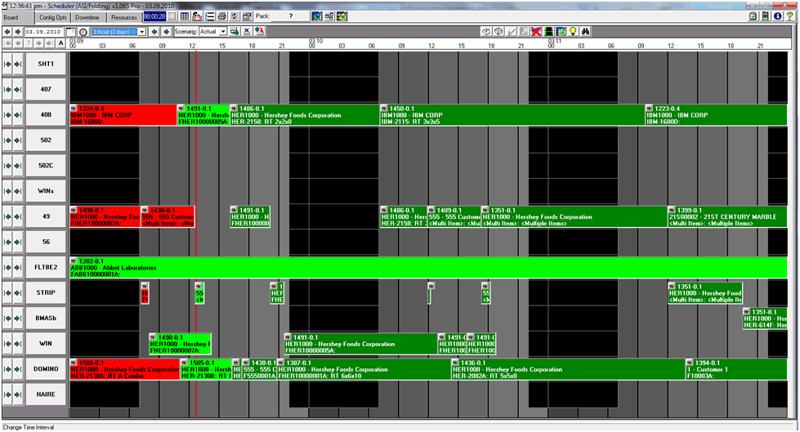

Table of Contents

Select ID & In Use List 11

Blue Screen Startup Processes 12

Config Opts (Configuration Options) tab 16

Color Settings 16

Color Pallet 16

Job Color Label Column 16

BG & FG Columns 16

Priority Column 17

Custom Color Label, Status Value, BG, FG & Priority Columns 17

External Program Load Setting 18

Set Job Color based on <Due> Source 19

Status Checkoff Default Settings 19

Save Selectionscommit.bmp 19

Restore from Last Saverollback.bmp 19

Default Settings 19

Board Settings 20

Valid Schedule Board ID’s 22

Pack Opt: 22

Resource Popup Settings 23

Pending Jobs 23

Scheduler Re-Start Required to take effect 23

Job Appearance 23

Priority Settings 24

Conflict Settings 24

Save Selectionscommit.bmp 24

Restore from Last Saverollback.bmp 24

Fields to Load 24

Save Selectionscommit.bmp 25

Restore from Last Saverollback.bmp 25

Downtime tab 25

Set Downtime Calendar View 26

Selecting a Resource (machine) 26

Enter Time Values 26

Save Time Entryadd.bmp 27

Remove Time Entrycancel.bmp 27

Open Entire Dayclock1.bmp 27

Special Time Entry 27

Save ALL Changes commit.bmp 29

Cancel ALL Changesrollback.bmp 29

Quick Copy/Delete 29

Copy Entries 30

Deleting Entries 30

Copy to Date 31

Exit exit1.bmp 31

Resources tab 31

Include option 32

Include w/o Jobs option 32

Exclude option 33

None option 33

Save ALL Changescommit.bmp 33

Restore to Last Saverollback.bmp 33

Priority List 33

Running Since Last Save Clock 33

External Status Checkoff 33

Job Load Source Prompt 34

Incorrect Version Encountered 35

Updates PendingviewTable.bmp 35

Browser Column Order and Report Layoutsgrids.bmp 36

Browser Customization Section 37

Add & Remove Columns 37

Change Column Order 38

Save Columncommit.bmp 38

Reset from Last Saverollback.bmp 39

Custom Report Layout Section 39

Creating/Editing a Custom Report Layout 39

Custom (naming a report layout) “Name:” 39

Select/Add a “Fields:” 40

Test Layout (Preview)print.bmp 41

Save Layoutcommit.bmp 41

Reset from Last Saverollback.bmp 41

Delete Layoutcancel.bmp 41

Copy (existing) Formatcopy.bmp 41

Excel Export Section 41

Add a Field 42

Remove a Field 42

Set Field Order 42

Save Layoutcommit.bmp 42

Reset from Last Saverollback.bmp 42

Test Excel (Preview) 42

Field Filter Section 42

Add/Remove a Field Range 43

Save Filter Fieldscommit.bmp 43

Reset from Last Saverollback.bmp 43

Using Report Writer to Set Job Object Text 43

Using Report Writer to Set Job Tool Tip 44

Sequencersetseq.bmp 45

Resource SequencermoveResource.bmp 45

Move Routing Upup.bmp 46

Move Routing Downdown.bmp 46

Refreshrollback.bmp 46

Exitexit1.bmp 47

Selecting a Resource 47

Selecting a Job 47

Return Job to Pending 47



Status Check Offsave.bmp 47

Job NotesnoteTack.bmp 47

Turn Job Detail OndetailWinOff.bmp OffdetailWinOn.bmp 47

Turn Job Highlight OnlightBulbOff.bmp OfflightBulbOn.bmp 47

Shift Job Sequence Upup.bmp 47

Shift Job Sequence Downdown.bmp 47

Save Sequence Changescommit.bmp 48

Reset Job Sequencesrollback.bmp 48

Exitexit1.bmp 48

Move ResourcemoveResource.bmp 48

Move to Resource popup selection and confirmation 50

Move Job(s) to Selected Resourcecommit.bmp 50

Exitexit1.bmp 50

Printprint.bmp 50

ASI Department Code popop 51

Save Department Codescommit.bmp 51

Reset Department Coderollback.bmp 51

Exit Department Codesexit1.bmp 52

Job Load Source Prompt 52

Incorrect Version Encountered 53

Reload Boardrefresh.bmp 53

Import Data CollectiondataCollection.bmp 54

Packing the Schedule Board 55

Pack by Job1408.gif 55

Pack by Resourcedomino1.gif 56

Pack All JobsentireBoard.bmp 56

Use/Do Not Use Job Sequence Values When PackinguseSequenceOn.bmpuseSequenceOff.bmp 57

Bring Past Jobs ForwardbringForward.bmp 57

Set Beginning Grid Date 58

Previous Dateprev.bmp 58

Next Datenext.bmp 58

Popup Calendarcalendar.bmp 58

Position Board to Current Date and Timeclock1.bmp 58

Select Grid Interval 58

Move Back by Interval 58



Move Forward by Intervalnext.bmp 59

Scenario: Actual 59

Save Scenariocommit.bmp 59

Remove Scenariorollback.bmp 59

Reset Board from Last Saverollback.bmp 59

Pending by Jobpending.bmp 59

Printprint.bmp 60

Job Status Check Offsave.bmp 60

Move Resource (machine)moveResource.bmp 61

Pending by ResourcependingJobs.bmp 62

Set Filter ValuesfilterWindow.bmp 63

Printprint.bmp 64

Job Status Check Offsave.bmp 64

Move Resource (machine)moveResource.bmp 64

Auto Sequencesetseq.bmp 64

Update Job 64

Job Status Check Offsave.bmp 67

Job NotesnoteTack.bmp 68

Add New Job Noteadd.bmp 69

Delete Job Notecancel.bmp 70

Save Job Notecommit.bmp 70

Reset Job Noterollback.bmp 70

Exit Job Notesexit1.bmp 70

Turn Date Prompt On/OffdateOff.bmpdateOn.bmp 70

Save Date and Timecommit.bmp 71

Reset Date and Timerollback.bmp 71

Cancel with No Changesexit1.bmp 71

Hide/Show DowntimedowntimeOn.bmpdowntimeOff.bmp 71

Job Detail Popup Off/OndetailWinOff.bmpdetailWinOn.bmp 71

Job Header tab information 71

Job Capacity Updatecommit.bmp 72

Job Capacity Resetrollback.bmp 72

Job Capacity Cancel Updatecancel.bmp 72

Job Items tab information 72

Job Materials tab information 72

Job Machine tab information 73

Job Department Notes tab information 73

Job/Routings tab 73

Job Status Check Offsave.bmp 74

Job NotesnoteTack.bmp 74

Job Data CollectiondataCollection.bmp 74

Turn Highlight Off/OnlightBulbOff.bmplightBulbOn.bmp 75

Job Browsefind.bmp 76

Set Filter ValuesfilterWindow.bmp 77

Printprint.bmp 78

Access Data CollectiondataCollection.bmp 79

Capacity ViewcapacityView.bmp 80

Refreshrefresh.bmp 82

Exitexit1.bmp 82

Calendarcalendar.bmp 82

Color Legendlegend.bmp 82

About (Support Contact Information) info.bmp 83

Clear Status CheckOffs 84

Clear Job Notes 84

Return Jobs to Pending 84

Move All Pending Jobs to the Board 84

Savecommit.bmp 85

Restorerollback.bmp 85

Help Documentationhelp.bmp 85

Resource (Machine) Detail Job Browse 85

Reposition to First Job for <Resource (machine)>first.bmp 85

Reposition to Last Job for <Resource (machine)>last.bmp 85

Detail Browser domino.gif 86

Set Filter ValuesfilterWindow.bmp 86

Printprint.bmp 87

Update Job Sequence and Lock Values 88

Access Data CollectiondataCollection.bmp 88

Toggle Live Update SettingliveUpdate.bmp 89

Lock Jobsunlocked.gif 89

Unlock Jobslocked.gif 89

Turn Job Display Window OndetailWinOff.bmp OffdetailWinOn.bmp 89

Turn Date Prompt Popup OndateOff.bmp OffdateOn.bmp 90

Lock Related Jobsunlocked.gif Unlock Related Jobslocked.gif 90

Auto Sequencesetseq.bmp 91

Increment Job Sequence Upup.bmp 93

Increment Job Sequence Downdown.bmp 93

Pack Selected JobentireBoard.bmp 93

Save (Pack Resource)commit.bmp 93

Advanced Job Drop & Drag Options 93

Move Job to another Resource (machine) 93

Drop and Drag Jobs to New Position 93

Slide to First Available Time 94

Insert Job/Push Existing Job(s) Back 94

Shift Sequence of Jobs 94

Leave As Is 94

Span Downtime 94

Slide to First Available Time After Downtime 94

Slide to First Available Time Before Downtime 94

Return Scheduled Job to Pendingpending.bmp pendingJobs.bmp 95

Accessing Job Notes via Pin IconnoteTackRed.bmp noteTack.bmp 95

Locking/Unlocking a Job via Lock Iconlocked.gif 95

CTRL Key Options (short cuts) 95

Lag Time (CTRL-L) 95

Save New Lag Time Valuecommit.bmp 96

Restore Original Lag Time Valuerollback.bmp 96

Cancel with No Changesexit1.bmp 96

Auto Find Next Job Routing (CTRL-N) 96

Auto Find Previous Job Routing (CTRL-P) 96

Status Check Off (CTRL-O) 96

Date Prompt (CTRL-D / CTRL-T) 97

Save (CTRL-S) 97

Reset (CTRL-R) 97

# Select ID & In Use List

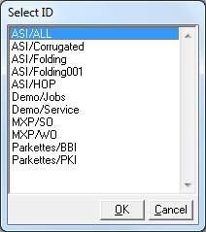If multiple Schedule Board options exist, the user will be prompted to select an ID under which the Schedule Board will operate.

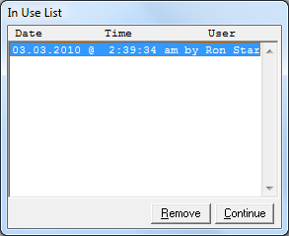

The Schedule Board is not designed to be multi user enabled; however, the Schedule Board does allow multiple users to access the Board simultaneously. If another user is already logged in the Schedule Board, an “In Use List” will pop-up, identifying other users currently logged in. If a Schedule Board session fails or for whatever reason the Schedule Board should exit prematurely, an “In Use List” user may not be valid. In this case, simply highlight the erroneous entry and click “Remove”. When finished viewing, click “Continue” to start the Schedule Board.

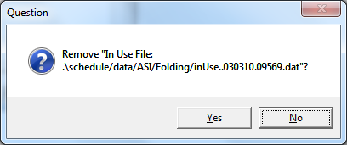

# Blue Screen Startup Processes

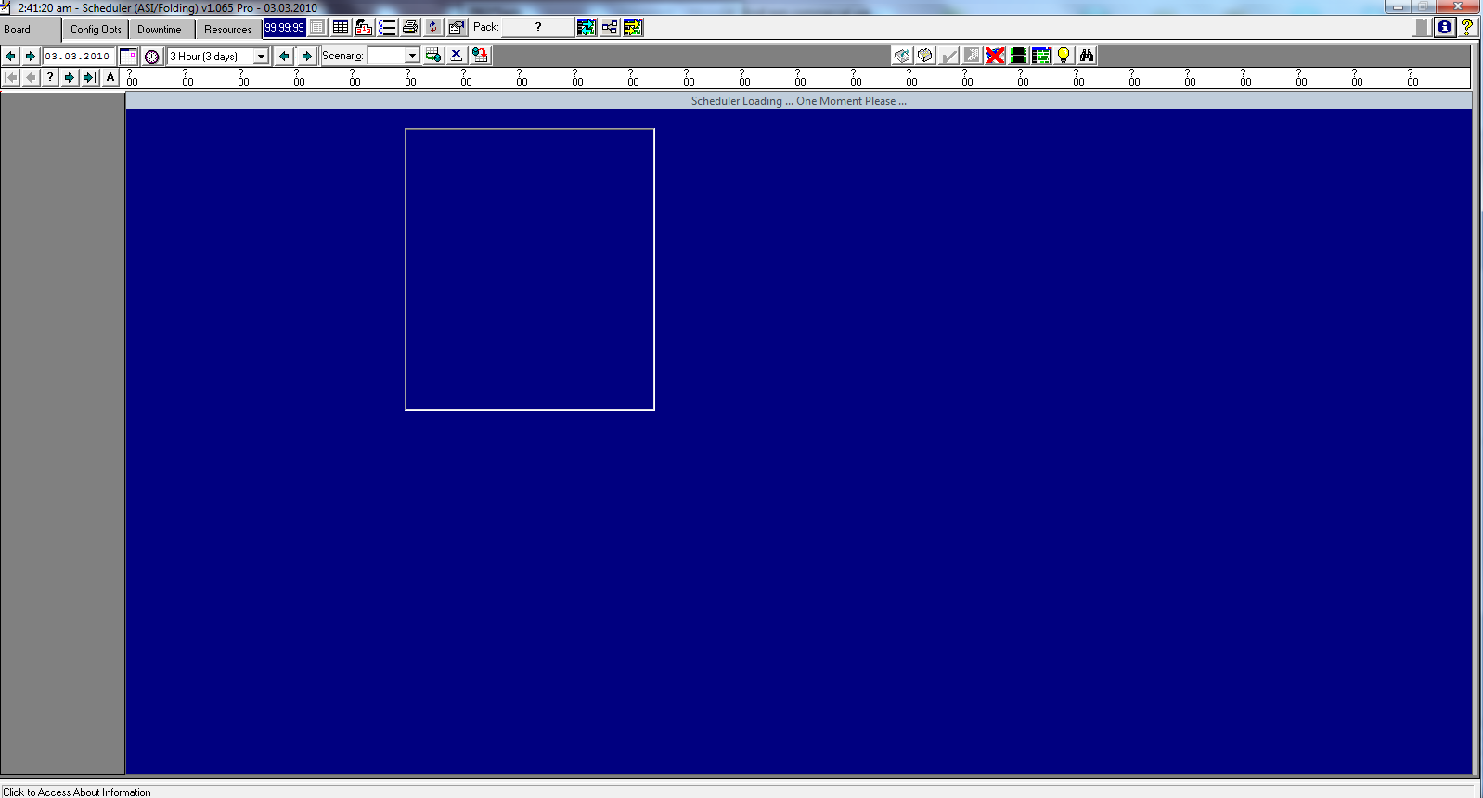During startup, a blue screen appears outlining in detail the various processes running before the Schedule Board is fully realized. Jobs will appear on the Schedule Board under the following criteria:

* Job status is OPEN.
* Job Routing has a status of Run Completed as NO.
* Job Routing Resource (Machine) has been designated for the Schedule Board.
* Job will appear on the Schedule Board if it’s Starting and Ending Date/Time fields have values.
* Job will appear in the Pending to be Scheduled if it’s Starting and Ending Date/Time fields have no values.
* Schedule Board data is entirely contained within ASI system’s J-U-1 Routing Tab.
* Any and all data changes done within the Schedule Board will only affect data under J-U-1 Routing Tab and DOES NOT in any way effect Estimates, Quotes and/or Orders.

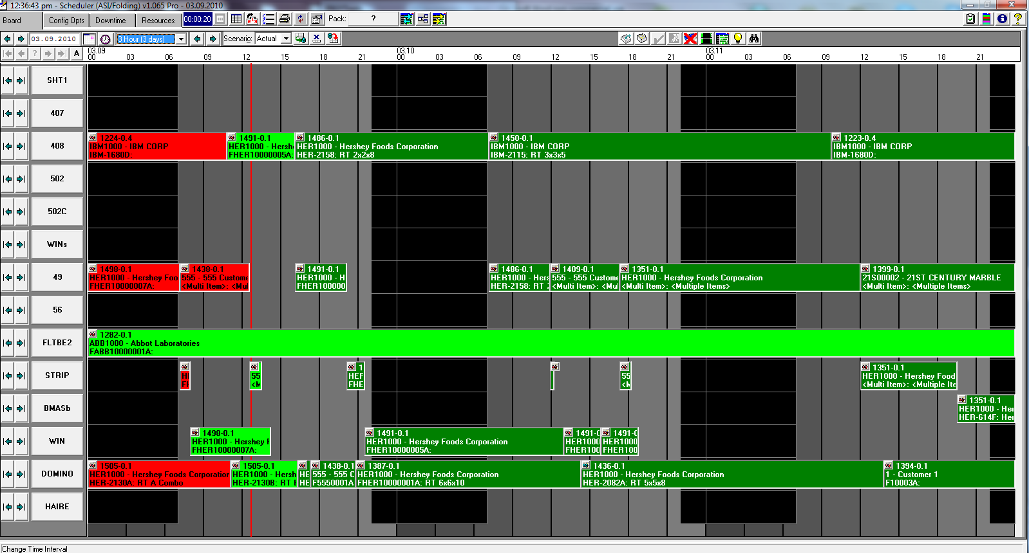Image: Schedule Board fully realized (the vertical “RED” line indicates the system current date and time)

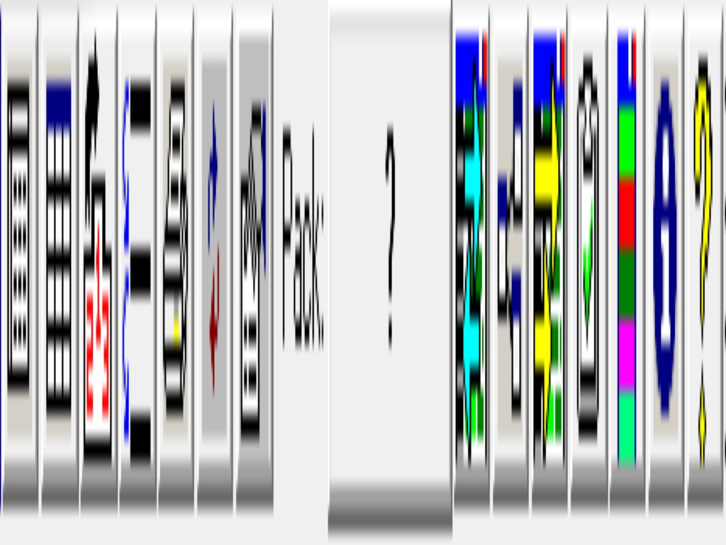Top row icon images Left to Right:

* viewTable.bmp Updates Pending
* grids.bmp Browser Column Order and Report Layouts
* setseq.bmp Sequencer
* moveResource.bmp Move Resource
* print.bmp Print (reports)
* refresh.bmp Reload Board, NOTE: this icon will appear in several pop-up’s indicating Refresh functionality exists, however, newer versions of the Schedule Board enhanced the ability of multiple processes to communicate with each other. Thus, any changes in one open module will auto trigger a Refresh in any other open module.
* dataCollection.bmp Import Data Collection
* 1408.gif selected Job, domino1.gif Resource (machine)
* entireBoard.bmp Pack All Jobs
* useSequenceOn.bmp Use Job Sequence Value when Packing, useSequenceOff.bmp Do Not Use Job Sequence Value when Packing
* bringForward.bmp Bring Past Jobs Forward
* capacityView.bmp Capacity View
* legend.bmp Color Legend
* info.bmp About (Support Contact Information)
* helpAbout.bmp Help (User Manual)

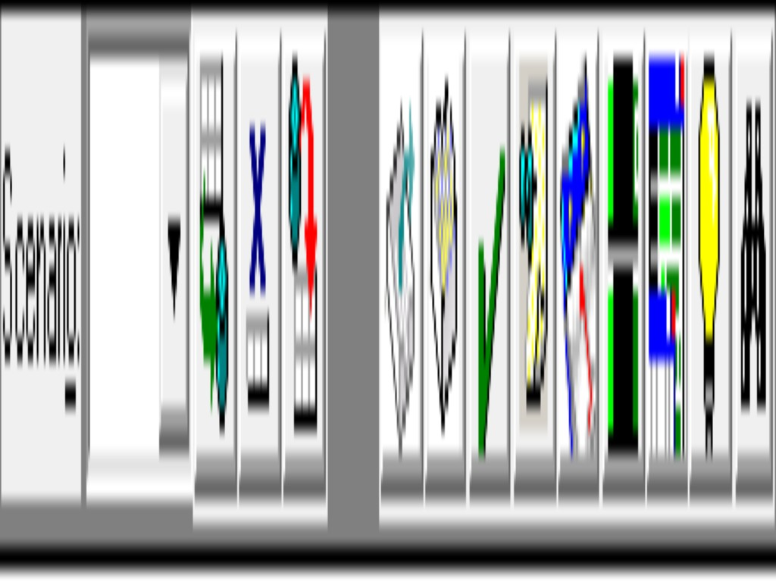Second row icon images Left to Right

* Scenario pull down (combo-box)
* commit.bmp Save Scenario
* cancel.bmp Remove Scenario
* rollback.bmp Reset Board from Last Save
* pending.bmp Pending by Job
* pendingJobs.bmp Pending by Resource
* save.bmp Complete Job (Job Status Check Offs)
* noteTack.bmp Job Notes
* dateOff.bmp Turn Date Prompt On, dateOn.bmp Turn Date Prompt Off
* downtimeOn.bmp Hide Downtime, downtimeOff.bmp Show Downtime
* detailWinOn.bmp Turn Detail Display Window Off, detailWinOff.bmp Turn Detail Display Window On
* lightBulbOn.bmp Turn Highlight Off, lightBulbOff.bmp Turn Highlight On
* find.bmp Job Browse

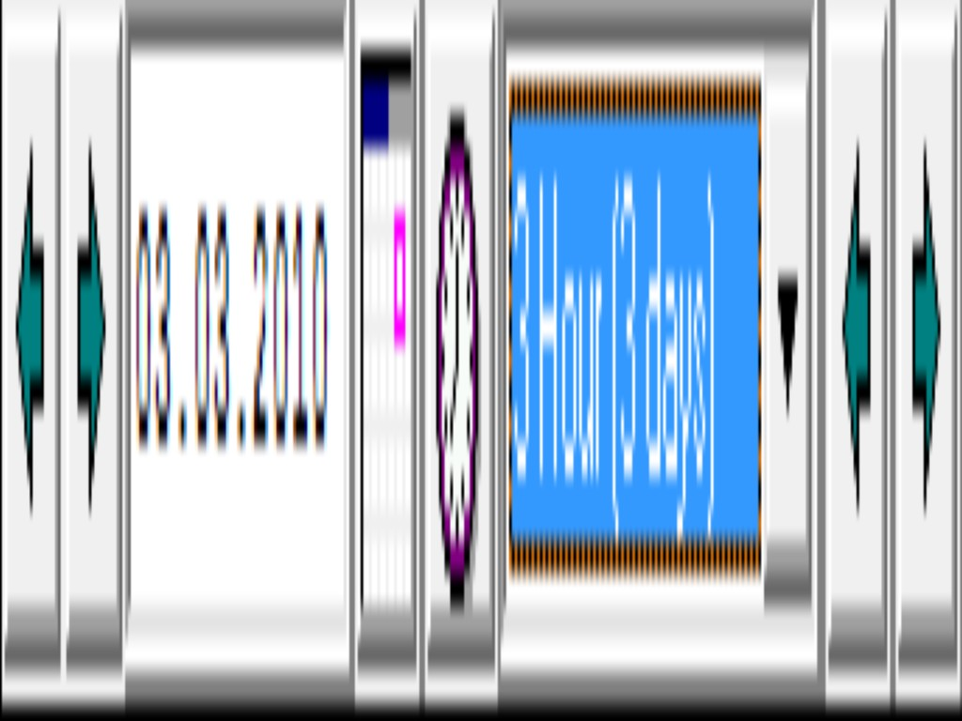Date and Time Navigation icon images Left to Right

* prev.bmp Previous Date
* next.bmp Next Date
* Set Beginning Grid Date field
* calendar.bmp Popup Calendar
* clock1.bmp Position Board to Current Date & Time
* Select Grid Interval pull down (combo-box)
* prev.bmp Move Back by Interval
* next.bmp Move Forward by Interval

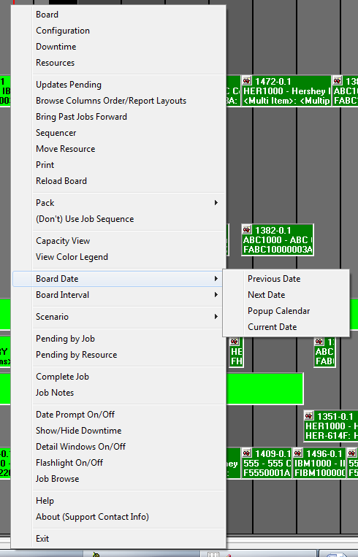Right-Mouse-Click Popup Menu will display from anywhere within the Schedule Board and contains all of the icon image functionality.

# Config Opts (Configuration Options) tab

Color Settings contains the default settings for Job colors and Status Check Off settings.

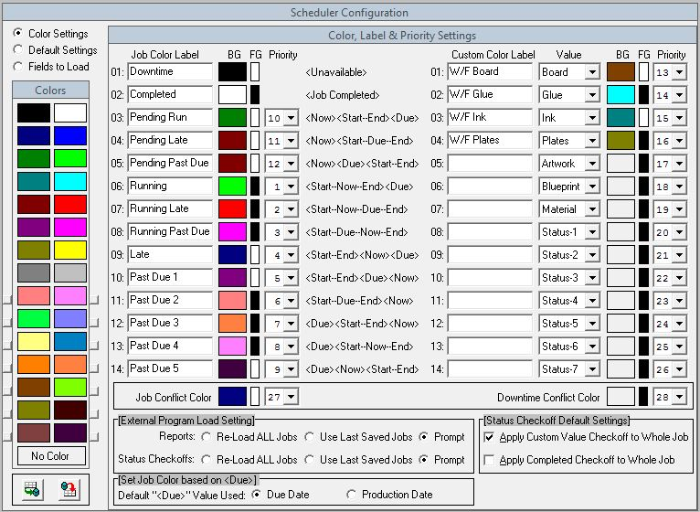

Color Pallet

The left side shows the 16 default colors and 14 colors that can be custom set by using Windows Color Dialog popup by clicking the small light gray buttons to the left or right of the lower 14 color blocks. An additional “No Color” option sits just below the 30 color blocks.

Job Color Label Column

There are 30 Priority Labels, 14 indicating the Job’s relationship to Time, 14 indicating the Job’s relationship to Status Check Off values and an additional 2 indicating a Job’s relationship to either downtime conflict or a conflict with another existing scheduled Job. The 14 Time labels and the 14 Status labels are set by the Schedule Board user.

BG & FG Columns

The columns labeled “BG” indicates the “Background Color” and the column labeled “FG” indicate the “Foreground Color”. The “BG” color is the base color for a Job and the “FG” color is the color of the text that appears within the Job object.

To set any color block, first select the color block to change, than select the color desired from the left side in the “Colors” frame.

Priority Column

The “Priority” column is used to decide which of the 30 Time/Status/Conflict indicators are used when display a Job’s color, thus giving a visual indicator to those viewing the Schedule Board. The Schedule Board will use the “Priority” values starting at 1 to check whether the Job’s data values match that particular “Priority”.

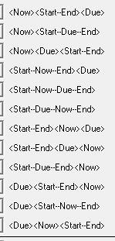There are three time elements associated with each Job.

1. A Job’s starting and ending date/time.
2. A Job’s due date/time.
3. A Job’s relation to a set point in time, such as the current date/time, indicated by “Now”.

“<Now><Start—End><Due>” shows a Job in relation to a point in time “<Now>”, it’s starting and ending date/time in the future and it’s due date/time after it is scheduled to be completed. Basically this Job has not started yet, and as currently scheduled will complete before it is due.

Another example, “<Start—Now—End><Due>” shows a Job that has started its run but has not yet completed, and will complete before its due date/time.

“<Start—Now—Due—End>”, shows a Job that is running, but it will not finish before it’s due date/time has expired.

An example to be on the lookout for is “<Now><Due><Start—End>” which shows a Job as currently scheduled will not start its run until after its due date/time has expired. Catching Jobs scheduled as such early, allows the Schedule Board user to re-schedule this Job to start before its due date/time has passed, thus potentially completing this Job on time.

Custom Color Label, Status Value, BG, FG & Priority Columns

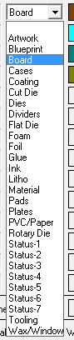

The second set of “Priority” indicators deal with a Job’s Status Check Off values. These are custom set by the user and can indicate most any type of issue an operation wishes to track. The most common type of Status Check Off values is “W/F Board” (waiting for board). If the ASI System is used to receipt board against Jobs, the Schedule Board will auto check this status and auto fill this Status Check Off value. Status Check Off values that will auto load are: Board (B), Cases (C), Coating (V), Cut Die (8), Dividers (6), Flat Die (X), Foam (1,2,3 & 4), Foil (F), Glue (G), Ink (I), Litho (L), Pads (5), Plates (7), PVC/Paper (P), Rotary Die (Y) and Wax/Window (W). The remaining Status Check Off values exist for backward compatibility.

External Program Load Setting indicates the source of where to load Jobs from.

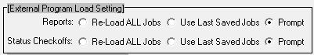

Re-Load ALL Jobs will cause any of the external programs to get ALL Jobs from system database, and takes the same amount of processing time as the Schedule Board during a load/reload operation. Use Last Saved Jobs will read the Jobs currently (last saved) from the Schedule Board. Any newly created Jobs within the system database that have not been loaded into the Schedule Board, will also not be accessible via any of the external programs. This option has the benefit of loading Jobs in the same manner as the Schedule Board View version. The Prompt option allows the user executing the external program to select to Re-Load or Use Last Saved as desired.

Set Job Color based on <Due> Source allows for using either the Due Date or Production Date when setting a Job’s color.

Untitled-31.gif

Color settings based on the Job’s relationship to time uses its Start/End, Due and Now (usually understood as the current time) values.

Status Checkoff Default Settings

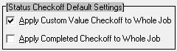

“Apply Custom Value Checkoff to Whole Job” and “Apply Completed Checkoff to Whole Job” are used as default settings that appear at the top of the “Status Check Off”save.bmp popup. How these values affect the behavior of the “Status Check Off” is described in this document further down.

Save Selectionscommit.bmp will apply any changes and auto reset the Schedule Board accordingly.

Restore from Last Saverollback.bmp will discard and reset any changes made since the last SAVE operation was executed.

Default Settings contains the default settings for Schedule Board behavior and functionality for various operations. These value settings can be thought of as a visual N-K-1 in the ASI System.

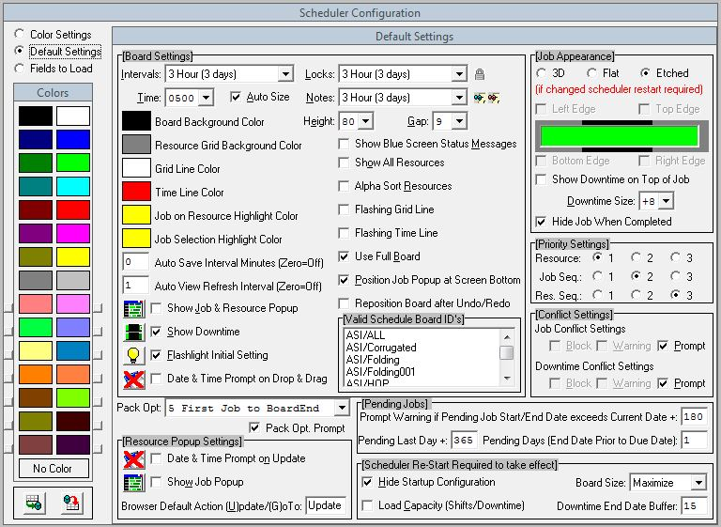

### Board Settings

Intervals: setting when the Schedule Board opens, valid values are featured below.

Locks:locked.gif interval setting upon which the Lock icon will appear on the Job object.

Time: when the interval setting is type Minute, the time setting field on the Schedule Board enables allowing the selection of the hour (in military time format 0000 to 2300) for the starting left edge time.

Auto Size if selected will auto size the Resource (machine) buttons and Job objects if based on the Height: and Gap: settings would cause them to be displayed beyond the visible screen. If this value is not selected, navigation controls enable to allow viewing of Resources (machines) and Job objects that are not visible because they extend beyond the visible screen area.

Notes:noteTackRed.bmp noteTack.bmp interval setting upon which the Note icon will appear on the Job object. A red note icon indicates no notes exist, if the green note icon is visible, then Job notes exist.

Height: value in pixels of the Resource (machine) and Job objects.

Gap: value in pixels of the vertical space created between each Resource (machine) and Job objects.

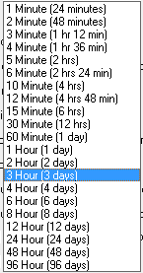Valid Interval values, two types exist in Minute and Hour settings.

Board Background Color is the color used behind the job objects and does a gradual color fade from left to right.

Resource Grid Background Color is what shows behind the Resource (machine) buttons.

Grid Line Color is how the horizontal line will appear when a job or resource (machine) is selected allowing a visual aid across the screen.

Time Line Color is the vertical line that indicates the current date and time.

Job on Resource Highlight Color shows to the left and right of the Resource (machine) button when a job and its related routings are selected.

Job Selection Highlight Color changes from a job’s current time/status color when selected.

Auto Save Interval Minutes prompts the user to save the board based on its value, 0 (zero) causes the auto save to be disabled.

Auto View Refresh Minutes indicates how often the Schedule Board View version auto refreshes the display so a view user does not have to manually perform this function.

Show Job & Resource PopupdetailWinOff.bmp detailWinOn.bmp sets the initial visualization for this icon.

Show DowntimedowntimeOff.bmp downtimeOn.bmp sets the initial visualization for this icon.

Flashlight Initial SettinglightBulbOff.bmp lightBulbOn.bmp sets the initial visualization for this icon.

Date & Time Prompt on Drop & DragdateOn.bmp dateOff.bmp sets the initial visualization for this icon.

Shoe Blue Screen Status Messages causes the blue screen showing the processes as they are executed each time any function is performed. NOTE: using this option slows the processing of operations given that the slowest function of any computer is its display functions.

Show All Resources causes all of the Resources (machines) in the ASI System to be displayed regardless of what options and selections exist in the Resource tab.

Alpha Sort Resources will show the Resources (machines) listed in alphabetical order. The normal display is based on ASI System department hierarchy.

Flashing Grid Line causes the horizontal line to flash every half second.

Flashing Time Line causes the vertical line to flash every half second.

Use Full Board and does not reserve any space for the job detail popup. The job detail popup will display as an overlay popup. Un-checking this option will reserve approximately a third of the screen space at the bottom.

Position Job Popup at Screen Bottom will ensure the job popup always positions itself at the bottom of the Schedule Board, otherwise is will display wherever the operating system decides it should appear.

Reposition Board after Undo/Redo no longer an applicable function because Undo/Redo options have been disabled.

Valid Schedule Board ID’s can assist in limiting the available Schedule Board types at startup. If only one value is selected, the prompt is bypassed and the single selection will load automatically.

Pack Opt: allows which of the eight options is the default selection, so that when the popup is visualized, the user can merely hit the ENTER key without using the mouse.

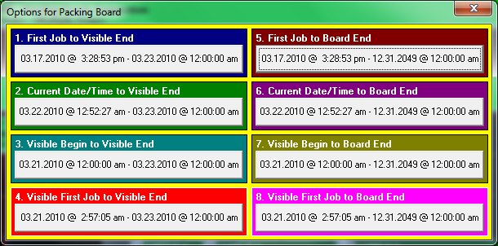

Pack Opt. Prompt causes the above prompt to display, otherwise, the packing option will auto select the Pack Opt. and execute its choice.

### Resource Popup Settings

Date & Time Promptdate.bmp dateOff.bmp on Update sets the initial visualization at startup inside the Resource (machine) popup, which is invoked when the Resource (machine) button is double clicked.

Show Job PopupdetailWinOff.bmp detailWinOn.bmp sets the initial visualization at startup inside the Resource (machine) popup, which is invoked when the Resource (machine) button is double clicked.

Browser Default Action (Update/GoTo) sets how the default behavior (double click or enter key press) of the browser inside the Resource (machine) popup, which is invoked when the Resource (machine) button is double clicked. It will either place the Job selected into Update mode or in the GoTo option, will cause the Schedule Board to be re-positioned to the highlighted Job.

### Pending Jobs

Prompt Warning if Pending Job Start/End Date exceeds Current Date +: provides a way to let the user know when a Pending Job moving to the Schedule Board exceeds the current date plus this value.

Pending Last Day +: prevents any Pending Jobs from being moved to the Schedule Board beyond the current date plus this value. Should a schedule job be placed too far into the future, the load/startup process may take an unacceptable amount of time to open.

Pending Days (End Date Prior to End Date): is the number of days prior to the job’s due date to calculate the minimal amount of time a job should begin production in order to meet its due date/time requirements.

### Scheduler Re-Start Required to take effect

Hide Startup Configuration prevents the configuration screen from showing when the Schedule Board opens each time. Uncheck this option if viewing the configuration screen is desired.

Load Capacity (Shifts/Downtime) causes the startup/load process to import the capacity values found in the ASI System for each Resource (machine) reverse converting into downtime values.

Board Size: allows the user to decide the Schedule Board size, the default setting is “Maximize” to take advantage of the entire screen real estate.

Downtime End Date Buffer: tells the Schedule Board how many days past the last scheduled job downtime should exist. An excessive number will cause the board to take longer to load.

Job Appearance (if changed restart required)

3D shows objects visually forward, uses five objects to create job, heavy overhead using this selection.

Flat no edgings, most efficient selection, uses only one object to create job.

Etched beveled edges inward, most common selection, uses only one object to create job.

Left, Top, Bottom & Right Edge toggle boxes will enable when the above 3D option selected. This allows what, if any edges will display around each job object.

Show Downtime on Top of Job when this option is selected. Normally the downtime objects will appear behind the job objects. Using this option blocks the text that is displayed on the job object.

Downtime Size is the pixels height relative to the job object size. The values range from +8 to -8 by increments of 2.

Hide Job When Completed occurs when this option is selected, otherwise the completed job inherits the color designated in the prior color settings screen.

Priority Settings is not applicable and exists for future enhancements.

### Conflict Settings

Job Conflict Settings dictates how the Schedule Board should behave when two or more jobs come into conflict with each other.

Block: prevents the conflict from occurring.

Warning: prompts the user that a conflict exists.

Prompt: will ask the user how to handle the conflict.

Downtime Conflict Settings dictates how the Schedule Board should behave when a job come into conflict with downtime.

Block: prevents the conflict from occurring.

Warning: prompts the user that a conflict exists.

Prompt: will ask the user how to handle the conflict.

Save Selectionscommit.bmp will apply any changes and auto reset the Schedule Board accordingly.

Restore from Last Saverollback.bmp will discard and reset any changes made since the last SAVE operation was executed.

Fields to Load allows for the selection of individual field values to be loaded into the Schedule Board. Selecting only those fields actually desired and not all of the fields possible will improve the load process time when starting and/or reloading the Schedule Board.

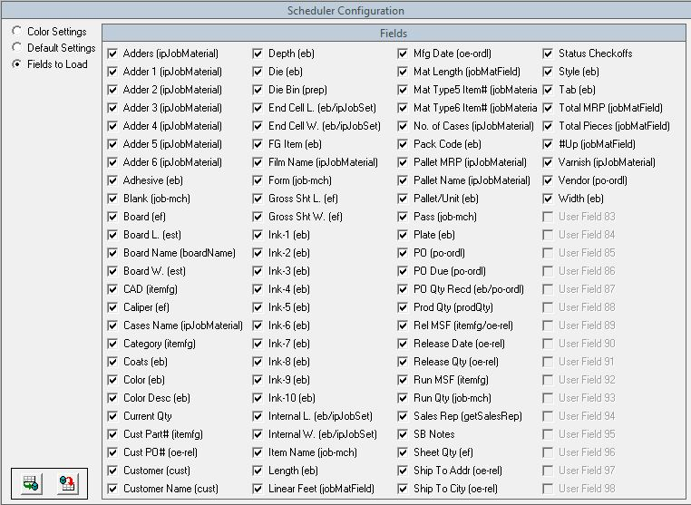

In parenthesis is shown which table and/or which procedure/function each field obtains its value. Please note that if at least one field is selected to load, that table and/or procedure/function will be executed, thus negating any load performance boost. All the fields for a table and/or procedure/function must not be selected in order to boost the load time performance.

Save Selectionscommit.bmp will apply any changes and auto reset the Schedule Board accordingly.

Restore from Last Saverollback.bmp will discard and reset any changes made since the last SAVE operation was executed.

Downtime tab allows entry of Downtime (time where the Resources (machines) are not available). The Downtime calendar is broken into various sections. Month/Year section sets the month and year to display. Resource (machine) section dictates which Resource (machine) the calendar entries apply, with “<Calendar>” being a special selection that causes the time entries to be applied across all Resources (machines). Red dates indicate weekend days (Saturday and Sunday), Yellow dates indicate weekdays (Monday through Friday). Blue week row is where time entries will apply to a specially selected Resource (machine). Cyan week row indicate the default time entries that apply if no Red, Yellow and/or Blue entries exist.

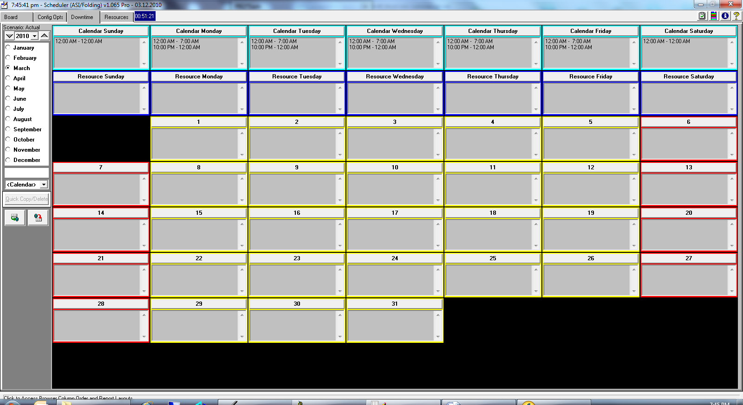

Set Downtime Calendar View by selecting the month and/or using the pull down (combo-box) for a desired year. The year value can also be set by using the up up.bmp or down down.bmp icons.

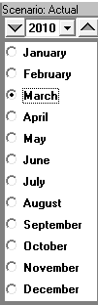Selecting a Resource (machine) for which the downtime entries will apply, by selecting a Resource (machine) from the pull down (combo-box) list. “<Calendar>” resource value causes any entry to be applied across all Resources (machines).

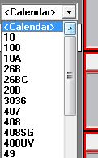Enter Time Values into the Downtime Calendar entails the user to click the button bar at the top of the desired day. After clicking the day bar, a time value popup appears just to the left of the day box showing a beginning and ending range. Enter the beginning and ending range values and selecting if it’s AM/PM. Remember, these values indicate when a Resource (machine) and/or all Resources (machines) are NOT available for scheduled Jobs.

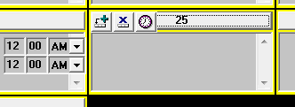

Save Time Entryadd.bmp places the time entries into the selected day.

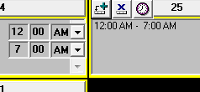

Remove Time Entrycancel.bmp requires the selection of a time entry that already exists and answering the following prompt.

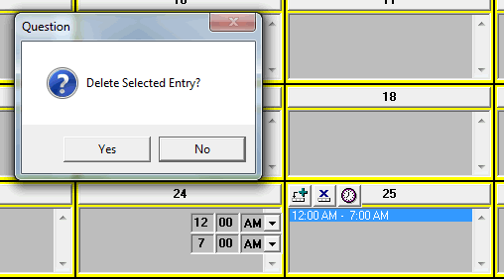

Open Entire Dayclock1.bmp allows an override entry. This type of entry will usually occur in a specific date and/or a Resource (machine) Weekday to cancel out the “<Calendar>” value entered in the Cyan colored row.

Special Time Entry, a 12:00AM to 12:00AM entry indicates a 24 hour period. Any other entry where the beginning and ending values are identical will indicate a zero time entry. Meaning, if a weekend entry normally shows no available time, in other words closed for the entire day (24 hours). An entry where a beginning and ending values are identical, it will calculate to zero and override the 24 hours that were originally indicating no time available for scheduled Jobs.

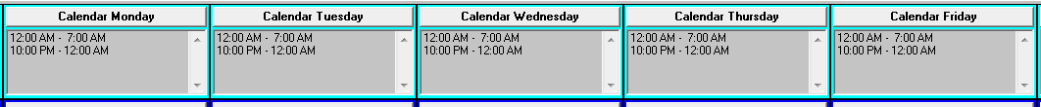

The above entries indicate that the normal operating hours are from 7AM to 10PM at night. Note, how it requires two entries on each day because the Downtime Calendar stores entries for when the Schedule Board is not available for scheduled Jobs. So, this example shows how the operating hours are not available from Midnight to 7AM and then is unavailable again from 10PM to Midnight. Similar entries would be required to show downtime for scheduled breaks and meal times.

In order to make time entries in the Blue row, a specific Resource (machine) has to be selected. No entries can be done when the Resource (machine) pull down (combo-box) is set to “<Calendar>”. Entries here usually indicate Resource(s) (machine(s)) that have a different operating schedule than is indicated in the general operating hours (Cyan days). If weekly preventative maintenance is part of the normal routine for a particular Resource (machine), this is where that type of time entry is made.

The general time entries are done from the top down, but are utilized by the Schedule Board from the bottom up. Base operating hours should be entered into the Cyan row for the seven days of the week.

If specific downtime for a Resource (machine) is needed, the Resource (machine) needs to be selected, than downtime entries are made to the Blue weekdays.

If specific downtime on a particular date is needed, it can be done for a specific Resource (machine) by selecting the Resource (machine) from the pull down (combo-box) list and then place the time entries in the desired date. Downtime can be entered for a particular date regardless of Resource (machine) when “<Calendar>” is selected.

Downtime is created based on the following criteria (once a calendar day, that has entries is located, the selection criteria will halt and the entries found are used to create the downtime:

1. A check is done for a Resource (machine) on each day of the calendar, Red/Yellow days.
2. Next, a check is done for “<Calendar>” on each day of the calendar, Red/Yellow days.
3. Next, a check is done for a Resource (machine) based on the day of the week, Blue days.
4. Last, a check is done for entries based on only the day of the week, Cyan days (this is done regardless of Resource (machine) selected).

Note: downtime will only be built from the earliest existing Job scheduled, regardless of whether prior downtime entries exist. The ending downtime entries are schedule based on the further (future) Job is scheduled plus “Downtime End Date Buffer:” value, which is found in the Configuration tab, Default Settings screen.

Untitled-18.gif This example shops that downtime will exist 15 days past the most future Job currently scheduled.

Save ALL Changes commit.bmp will apply all downtime changes. This operation will cause the Schedule Board to auto rebuild to apply the downtime changes done, thus a noticeable pause will occur.

Cancel ALL Changesrollback.bmp will cause any changes done to be discarded with no effect to the Schedule Board.

Quick Copy/Delete allows for quick cut/copy/paste operations for complicated Downtime settings from one Resource (machine) to another. This process is meant to be a time saver when numerous entries are required, particularly for many Resources (machines) that have extremely similar type operating and downtime hours.

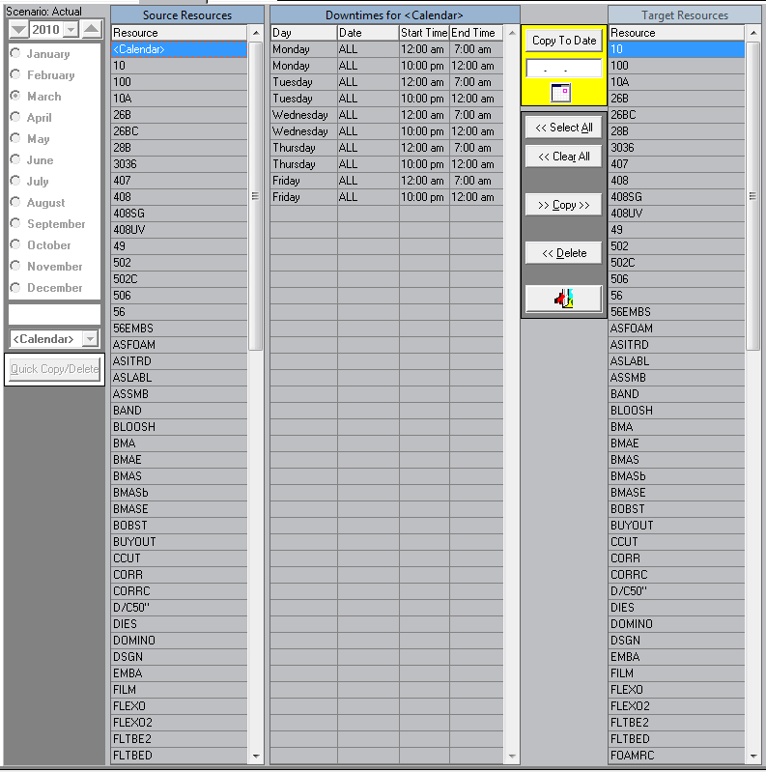

Copy Entries can be viewed for each Resource (machine) by making a selection from the “Source Resources” browser. To make Quick copies, select a downtime entry or multiple downtime entries using the CTRL key.

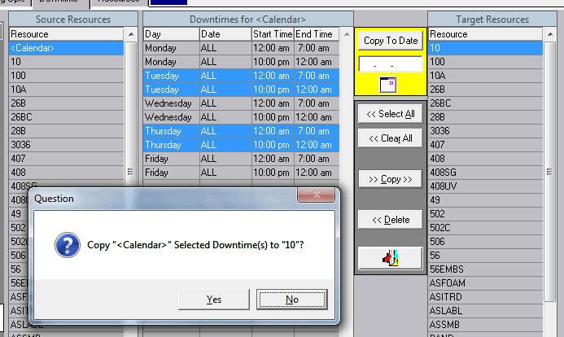

Next, select a Resource (machine) from the “Target Resources” browser. Then click the “>> Copy >>” button and answer the ensuing prompt.

Deleting Entries, can similarly be done, by selecting a Resource (machine) from the “Source Resources” browser entries can be quickly deleted.

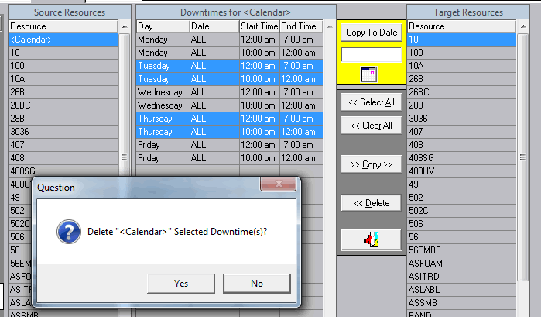

After selecting a downtime entry or multiple downtime entries and clicking the “<< Delete” button and answering the prompt.

Copy to Date, Entries can be selected and moved to a particular date. Enter a date or select a date from the calendar popup, then click the “Copy to Date” button.

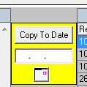

Exit exit1.bmp will close the Quick/Copy screen and return to the Downtime Calendar screen.

Resources tab allows for the selection by including/excluding Resources (machines) that exist within the ASI system.

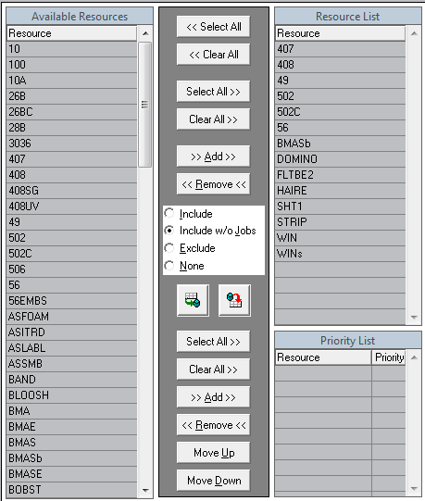

All the available Resources (machines) setup in the ASI System are listed in the left side browser. Simply double click or select an item, click the ADD button to move the selected Resource (machine) to the right side Resource List browser. Using the CTRL key, a user can select multiple Resources (machines) from either side and perform any of the various functions to ADD, REMOVE and/or CLEAR the selections.

Include option indicates that the Resources (machines) in the right side browser, Resource List will appear on the Schedule Board if and only if at least one Job is currently scheduled. If no Jobs exist for a Resource List Resource (machine), then the Resource (machine) will not appear.

Include w/o Jobs option indicates that all the Resources (machines) listed in the Resource List browser will appear on the Schedule Board regardless of whether the Resource (machine) has any Jobs scheduled. This is probably the most optimal option. It allows the precise selection of the desired Resources (machines) to be scheduled. It also allows Resources (machines) without Jobs scheduled to appear, thus retaining the ability to move Jobs from one Resource (machine) to another.

Exclude option indicates that all the Resources (machines) listed in the Resource List browser will NOT appear on the Schedule Board, regardless of whether any Jobs exist that are scheduled. Only Resources (machines) with Jobs schedule and not listed will appear on the Schedule Board.

None option indicates that regardless of what appears in the Resource List browser, only Resources (machines) with Jobs scheduled will appear on the Schedule Board. This could cause Resources (machines) that are not desired to be scheduled to appear.

Save ALL Changescommit.bmp will cause the following prompt:

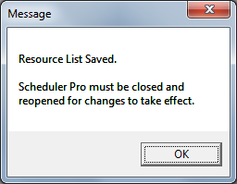 After applying any changes, the Schedule Board needs to be either Closed and Re-Opened or a Re-Load must occur in order for the changes to take effect.

Restore to Last Saverollback.bmp will undo any changes done since the last SAVE option was executed.

Priority List functionality does not currently have any effect at all. This exists for future development geared toward allowing the Schedule Board to be weighted by the Priority List browser values.

Running Since Last Save Clock is the “Blue” running time which indicates when the Schedule Board was opened and/or when the last SAVE operation was executed. This gives the users of the Schedule Board an indication of how “stale” the current Schedule Board data is in relation to the current data existing in the ASI system.

External Status Checkoff is accessed from the ASI System main menu.

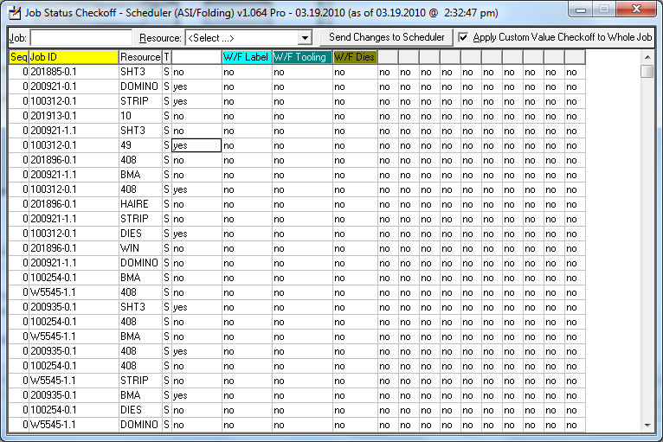

Jobs can be selected by highlighting a Job line or simply type in the Job ID value desired and the browser will auto filter each key stroke. Jobs can be filtered by Resource (machine) from the pull down (combo-box) list. The “T” (type) column indicates whether a Job is currently “S” scheduled or “P” pending. Once the desired Job is located, click on the Yes/No value under the Status column. Set the Status Check Off value accordingly. When all Status Check Offs are updated as desired, click the “Send Changes to Scheduler” button. This will generate a file that triggers the Schedule Board that “Updates are Pending” as indicated by the flashing title bar in the Schedule Board. When “Apply Custom Value Checkoff to Whole Job” is selected, any Status Check Off value changes will apply to the entire Job Routing and not just the selected Job/Resource (machine). Unchecked, then only the Job/Resource (machine) will have the value applied when the Schedule Board operator accepts any External Status Check Off values.

Job Load Source Prompt

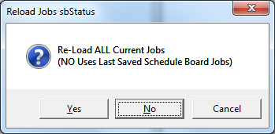

The above prompt will appear if the setting in the configuration tab is set as Prompt.



Incorrect Version Encountered

If the option to load the Jobs is from the Schedule Board Last Saved, but the current version of the program does not match the version when the last Save occurred the following error will be presented.

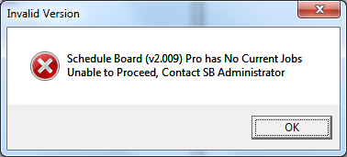

The Schedule Board administrator simply needs to run the Schedule Board Pro and perform a Save operation.

Updates PendingviewTable.bmp will enable when external updates to Job(s) Status Check Off’s have been sent from users outside of the Schedule Board. The Schedule Board title bar will automatically start flashing “(Updates Pending)” and enable the Updates Pending icon for selection. This capability allows organizations to decrease the amount of communications that occur with personal and departments. External users can communication the arrival and/or delays of such items as Dies, Art Work, Tooling, etc.

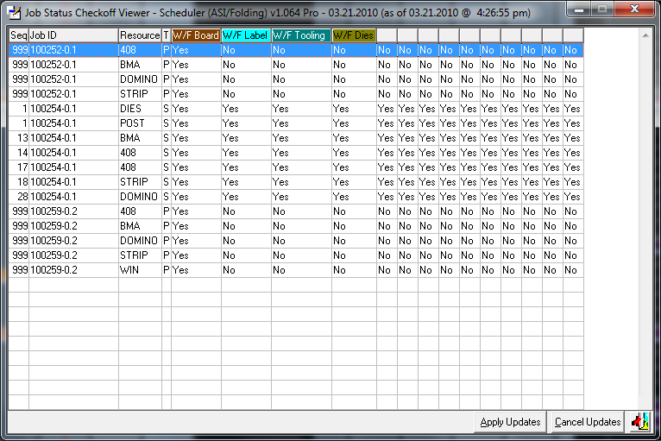

“Apply Updates” allows the Schedule Board user to apply the updates to the various status of Jobs without having to manually apply these updates. “Cancel Updates” will discard the updates sent to the Schedule Board. Invoking this function will in effect be as if the updates where never sent. If done inadvertently, the updates would have to be re-sent by the external users. Exitingexit1.bmpwill not cause any updates, nor discard the updates. The Schedule Board title bar will continue to flash the existence of “(Updates Pending)”.

Browser Column Order and Report Layoutsgrids.bmp has the ability for users to add, move and remove browser columns, create up to nine customer report versions for each existing report, decide layout for all reports utilizing Excel exporting and alter the fields used for filtering reports and browser data selection.

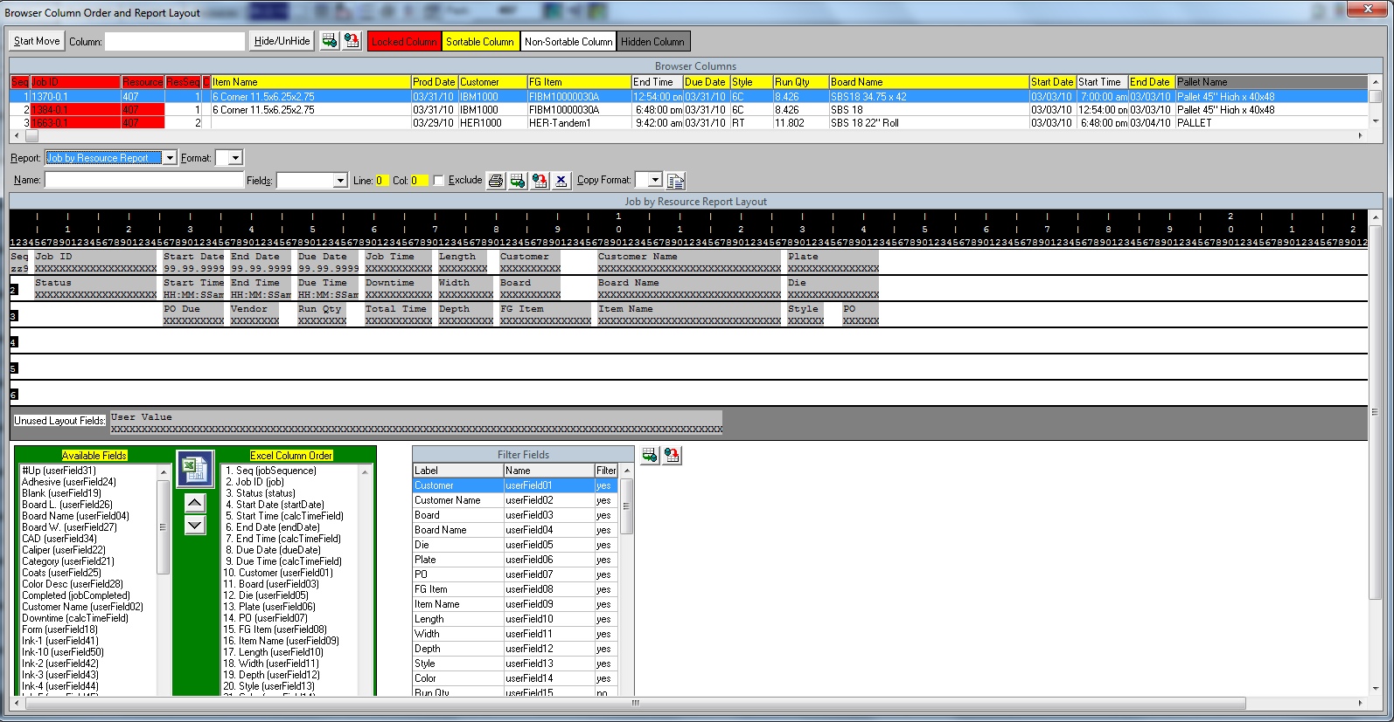There are four sections in this module. There is a section for customizing the browsers by letting a user decide which columns will appear or not appear and the order in which they appear. The second section allows for up to nine custom versions of the reports utilizing within the Schedule Board. The third section can be used to customize the Excel export functionality and the fourth section is where the beginning and ending field range values are decided, which are used in the field filter and print popup modules. Any SAVEcommit.bmp and/or RESETrollback.bmp operations will cause the module to auto close and re-open to affect the function executed.

Browser Customization Section has the function to select/unselect field columns and also to dictate the column order, with the exception that the first five fields, highlighted in RED cannot be removed and/or have their order changed.

### Add & Remove Columns

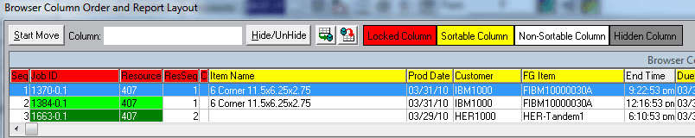

To remove a column, click the label header, for example “Prod Date”. In the field labeled “Column:”.

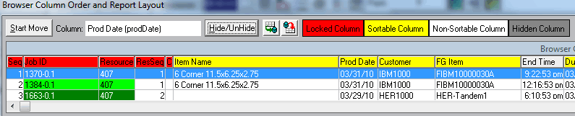

To remove the column, click the “Hide/UnHide” button. When a column is originally yellow (meaning it is sortable), it will change to a dark gray color. If it’s dark gray, it will change to yellow (or light gray, meaning it is not sortable, usually fields that hold Time values).

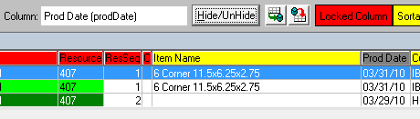

Change Column Order, click the “Start Move” button. The button label will change to “Stop Move”.

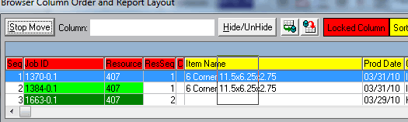

Now select any column (except those with RED labels) and while holding the mouse down, drag the column (an outline will appear) to the desired location.

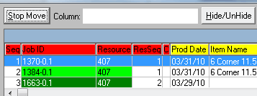When finished, click the “Stop Move”.

Save Columncommit.bmp changes to apply, the module will auto close and re-open, having saved and displaying browser changes.

Reset from Last Saverollback.bmp will undo any changes by auto closing and re-opening the module without applying any of the changes.

Custom Report Layout Section allows up to nine custom versions of the Schedule Board reports. If Schedule Board Notes exist (not ASI Job Ticket Notes), they will appear in any of the Schedule Board reports automatically. Schedule Board reports DO NOT contain any type of sub-totals or totals of any sort. This functionality is a scaled down ad hoc reporting module and not meant to replace a more robust reporting system, such as Cyrstal Reports, etc.

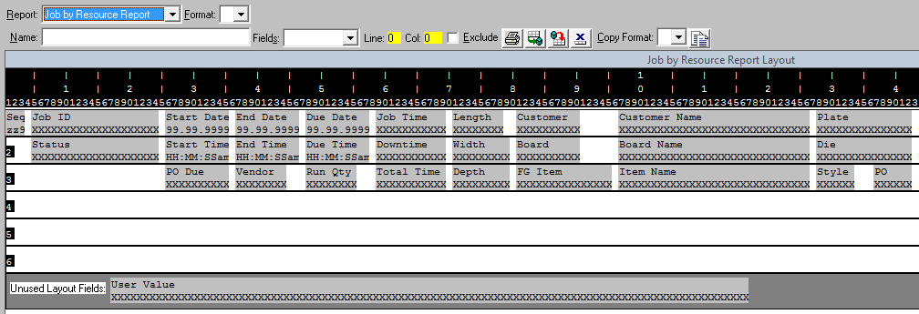Select one of the seven provided reports to work with. All base reports are stored as “Format:” BLANK” (no changes are permitted to any report with a BLANK “Format:” value) and custom created reports have a “Format:” value ranging from 1 to 9, which allow custom changes to be made.

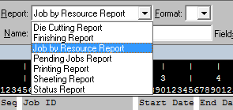 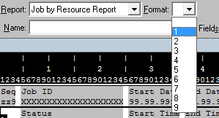

Creating/Editing a Custom Report Layout. After selecting a non blank format, if the custom report already exists it will load, if not, a blank report layout is presented.

Custom (naming a report layout) “Name:” can be entered for display when user’s access the Printprint.bmp is invoked.

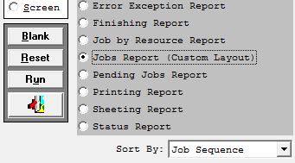

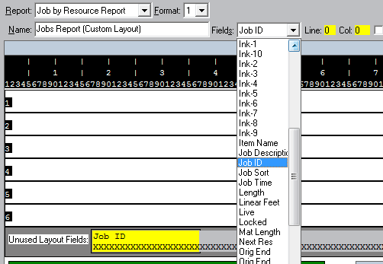

Select/Add a “Fields:” value and it is highlighted in the “Unused Layout Fields:” area or if it already exists in the report layout, it will highlight to yellow. When a field is highlighted or selected, it can be placed anywhere within the six line grid.

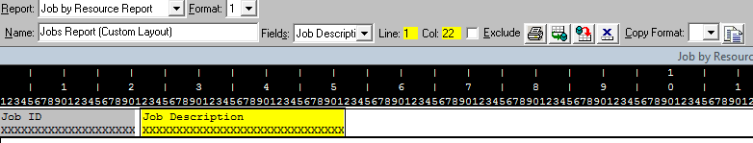

Whenever a field is selected and/or placed, the “Line:” and “Col:” values are displayed to assist in more accurate field placement. The “Exclude” toggle-box can be utilized to suppress the report from being made available. The “Skip Line” field is a specialized field that can be placed on the layout to create a blank line between each report line of data.

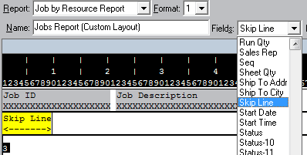

Test Layout (Preview)print.bmp will run the selected report to screen output (notepad), a SAVEcommit.bmp function must occur first before any changes can show in the Preview.

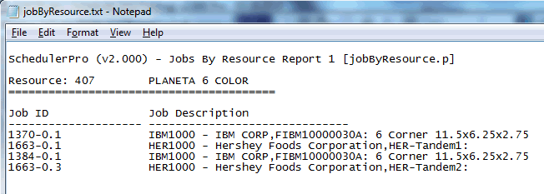

Save Layoutcommit.bmp applies any custom changes done to the selected report layout.

Reset from Last Saverollback.bmp restores any custom changes back to the last SAVE operation preformed.

Delete Layoutcancel.bmp removes the currently selected layout, however, BLANK “Format:” layouts cannot be deleted.

Copy (existing) Formatcopy.bmp allows a user to copy an already existing report layout to be loaded into a newly created report layout as a starting point. Once loaded, changes can be made to further customize the report layout.

Excel Export Section gives the ability to dictate how the Excel Exporting function will layout.

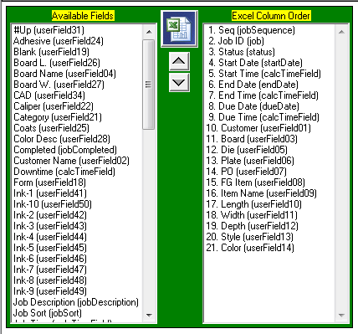

Add a Field to export by double clicking the left Available Fields browser and it will auto move to the right Excel Column Order browser.

Remove a Field by double clicking the right Excel Column Order browser and it will auto move back to the left Available Fields browser.

Set Field Order by highlighting any field in the left Excel Column Order browser and clicking either the upup.bmp icon or the down down.bmp icon.

Save Layoutcommit.bmp applies any custom changes done to the selected Excel layout. NOTE: this is the SAVE icon associated with the report layout section.

Reset from Last Saverollback.bmp restores any custom changes back to the last SAVE operation preformed. NOTE: this is the Reset icon associated with the report layout section.

Test Excel (Preview) by clicking the Excel excel.bmp icon. A SAVE operation must have been executed before showing the changes in Preview mode. NOTE: Microsoft Excel must be installed on the local machine running the Schedule Board session.

Field Filter Section allows users to decide the beginning and ending field ranges appear on the Field FilterfilterWindow.bmp and the Printprint.bmp popups.

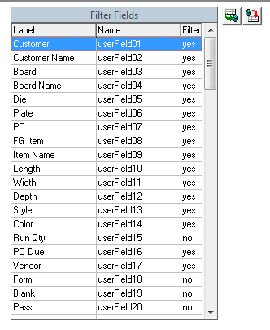

Add/Remove a Field Range by double clicking into the “Filter” column and the value to either “yes” or “no”. “Yes” indicating the field range will display and “No” indicating the field range will not display.

Save Filter Fieldscommit.bmp will apply any “yes/no” value changes.

Reset from Last Saverollback.bmp will restore the “yes/no” values from when the last SAVE operation was performed.

Using Report Writer to Set Job Object Text. To change the text that appears on the Job Object, select Report “Job Text”, select a Format 1 thru 9 and execute the Copy Functioncopy.bmp. A user can place up to six lines of text on the Job Object by following this simple rule. The highest numbered format that exists will be used to set the Job Object text. The first field of each line must be set in column 1 (one). A “ – “ (dash) will be placed between fields appearing on the same line.

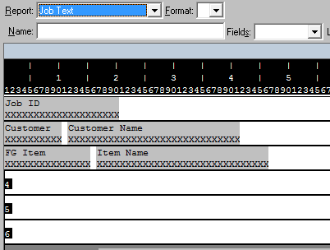

The above sample would show the Job# on line 1, Customer ID and Customer Name on line 2 and FG Item and Item Name on line 3. (this is the default setting and cannot be altered because it’s format value is blank)

Using Report Writer to Set Job Tool Tip. To change the text that appears on the Job Object Tool Tip, select Report “Job ToolTip”, select a Format 1 thru 9 and execute the Copy Functioncopy.bmp. A user can place up to six lines of text on the Job Object Tool Tip, by following this simple rule. The highest numbered format that exists will be used to set the Job Object Tool Tip. The first field of each line must be set in column 1 (one). A “ – “ (dash) will be placed between fields appearing on the same line.

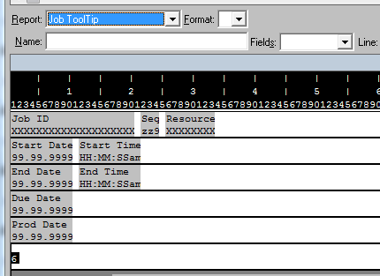

The above sample would show the Job#, Resource Sequence and Resource on line 1, Start Date and Time on line 2, End Date and Time on line 3, Due Date on line 4 and Production Date on line 5. A Job’s current status is always added as the last line by default. (this is the default setting and cannot be altered because it’s format value is blank)

Sequencersetseq.bmp provides the ability to alter the sequence of Jobs on a Resource (machine) by Resource (machine) basis. Warning, this can be one of the most disruptive operations with the Schedule Board. One of the universal rules within the Schedule Board is to respect the Job sequence of each Resource (machine). By changing the sequence of Jobs on one Resource (machine) may heavily impact another Resource (machine) that a moved Job on the selected Resource (machine) has a related routing. If a Job is moved further down the sequence and has related routings on other Resources (machines), it could potentially shift numerous Jobs further into the future, creating large time gaps because this process will not alter the existing Job sequence of the other Resource (machine) routings.

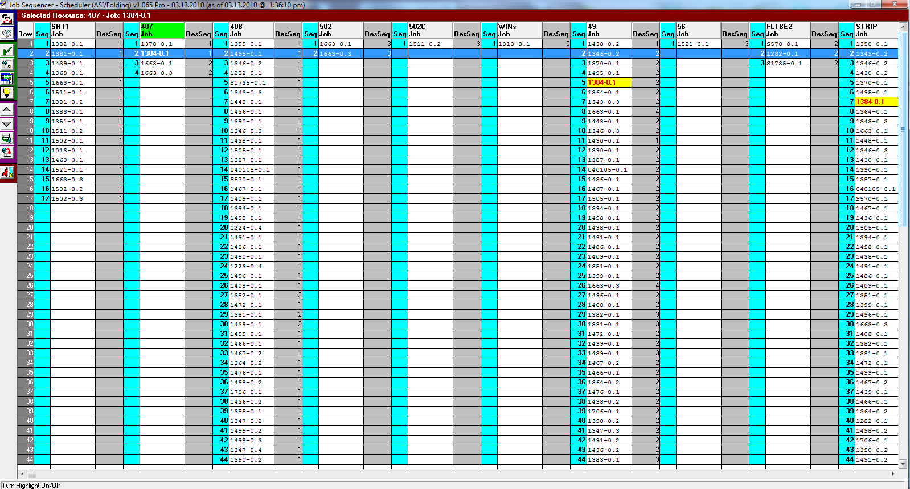

Resource SequencermoveResource.bmp will invoke a popup module which allows the changing of the Job Routing originally set from the Estimate in the ASI System. Any alterations done here are recorded as Real Time updates to the ASI System.

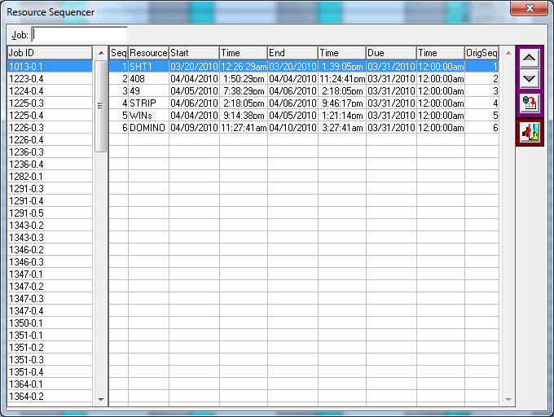

Desired routing changes for a Job are done by entering the Job number in the “Job:” field or selecting the Job from the “Job ID” browser on the left. Once the desired Job is located, select which routing on the right needs to be moved.

Move Routing Upup.bmp in Sequence up one position from the current position.

Move Routing Downdown.bmp in Sequence down one position from the current position.

Refreshrollback.bmp the routing sequence and answer the ensuing prompt.

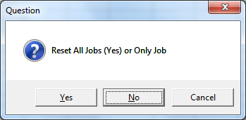

“Yes” will restore all the Job changes, “No” will only reset the selected Job or “Cancel” the Refresh.

Exitexit1.bmp the Resource Sequencer.

All of the the following icon functions require that a Resource (machine) and Job be selected prior to execution of the clicked icon.

Selecting a Resource requires the user to click the label of the Resource (machine) desired.

Selecting a Job is done by selecting the row within the browser where the desired Job appears.

Return Job to Pending allows any selected Job to be returned to Pending (along with all of the Job’s related routings). The user is prompted to select the routings to return to Pending. Thus, one or more of a Job’s Routings can be returned.



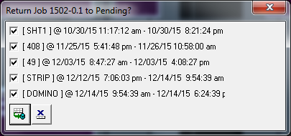

Status Check Offsave.bmp will invoke the Status Check Off popup. Documentation of this popup can be found further down within this document.

Job NotesnoteTack.bmp causes the Notes popup for the selected Job to appear. Documentation of this popup can be found further down within this document.

Turn Job Detail OndetailWinOff.bmp OffdetailWinOn.bmp, when this function is set to ON, the Job Detail popup will appear each time a Job is selected. Documentation of this popup can be found further down within this document.

Turn Job Highlight OnlightBulbOff.bmp OfflightBulbOn.bmp, when this function is set to ON, any related Routings for a selected Job will appear highlighted in Yellow and Red foreground text.

Shift Job Sequence Upup.bmp is used to move a selected Job up in the selected Resource (machine) production order.

Shift Job Sequence Downdown.bmp will cause the selected Job to be moved down in the selected Resource (machine) production order.

Save Sequence Changescommit.bmp applies any Job sequence changes done to any all Resources (machines). After this operation is selected, the user is prompted with the Resource (machine) packing options.

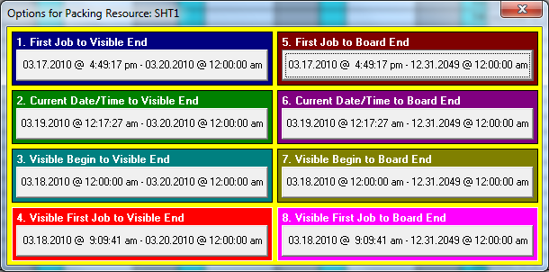

Documentation of this popup can be found further down within this document. Again, it is imperative that the Schedule Board user fully understand the effect of changing a Resource (machine) Job order and how any option selected above will affect the entire Schedule Board.

Reset Job Sequencesrollback.bmp will undo and discard any changes done since the last SAVE & PACK operations were performed.

Exitexit1.bmp Job Sequence module.

Move ResourcemoveResource.bmp allows for multiple Jobs to be moved from one Resource (machine) to another.

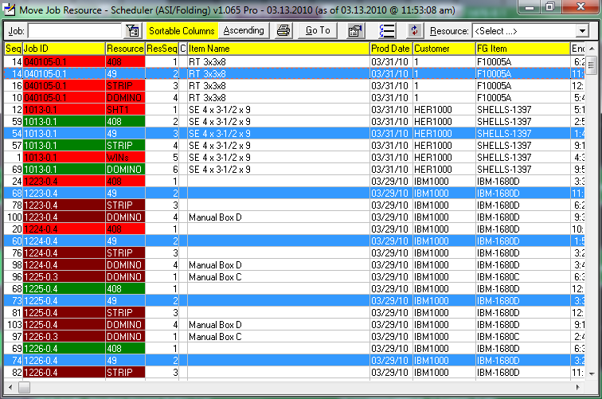This module contains many of the same functionality as the Job Browser find.bmp module. The additional functionality allows a user to select a Job (use the CTRL key to select multiple Jobs). After highlighting desired Job(s) to move, select Move Resource moveResource.bmp icon.

## Move to Resource popup selection and confirmation

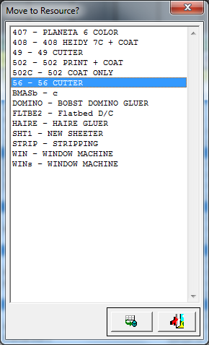

The Move Resource popup is accessed, which allows the user to select which Resource (machine), the previously selected Job(s), are now re-assigned (moved).

Move Job(s) to Selected Resourcecommit.bmp will move selected Job(s) to the selected Resource (machine).

Exitexit1.bmp move to resource module.

Printprint.bmp accesses Schedule Board reports.

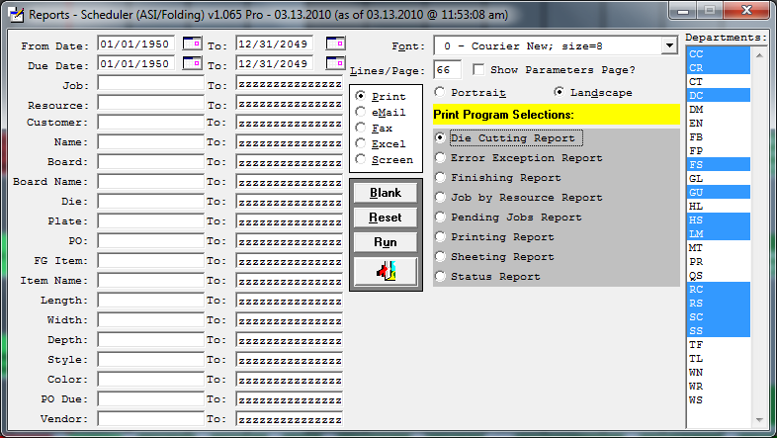The left side portion allows entry of beginning and ending value ranges used in any of the selected reports. All reports can be output to any printer connected to the work station emailed, faxed, exported to Excel and/or output to the screen (output runs to Notepad). Users can select desired Font size, number of lines per page, Portrait or Landscape orientation. All of the parameters used to generate a selected report can be output to a Parameter’s Page at the beginning of the report output. Selected reports can be filtered based on selected department codes. User’s simply click a desired code and use the CTRL to select multiple codes. To set department code defaults, RIGHT-MOUSE-CLICK with the department code selection list to invoke the ASI Department Code popup.

## ASI Department Code popop

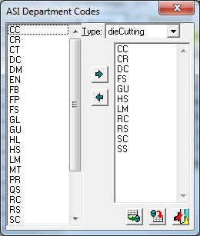The user selects the report Type from the pull down list (combo-box). Add codes from the left side selection list by double clicking the code or highlight a desired code (use the CTRL key to select multiple codes) and click next.bmp to add the selected code(s) to the right side selection list.

To remove department code(s) from a selected report type, select the department code (use the CTRL key to select multiple codes) and click prev.bmp to remove the selected code(s) back to the left side selection list.

Save Department Codescommit.bmp commits any department code changes.

Reset Department Coderollback.bmp will restore any changes done since the last SAVE operation was executed.

Exit Department Codesexit1.bmp closes the department code popup.

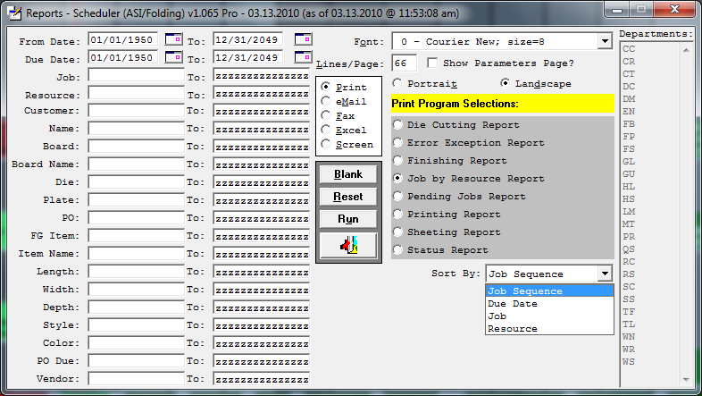Several of the Schedule Board reports have a “Sort By” option allowing users to select desired report output. All of the Schedule Board reports can have up to nine custom versions created using the Browser Column Order and Report Layouts grids.bmp module. Customizing the beginning and ending range fields and layout for the exporting to Excel are also done within the grids.bmp module.

Job Load Source Prompt when running the external version of the Schedule Board Reports from the ASI Main Menu.

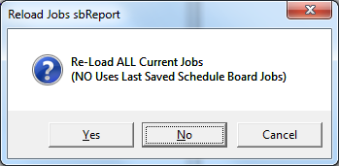

The above prompt will appear if the setting in the configuration tab is set as Prompt.



Incorrect Version Encountered

If the option to load the Jobs is from the Schedule Board Last Saved, but the current version of the program does not match the version when the last Save occurred the following error will be presented.



The Schedule Board administrator simply needs to run the Schedule Board Pro and perform a Save operation.

Reload Boardrefresh.bmp allows for the Schedule Board to reload its Job data without having to close and re-open the Schedule Board.

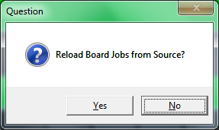User’s are prompted to execute the re-load. NO, will cancel the re-load request. YES, causes a prompt to SAVE the current Schedule Board before performing a re-load operation.

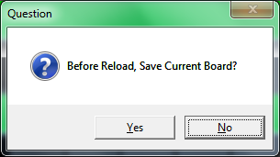NO, will not perform a SAVE operation, which in effect cancels any changes that might have been done since the last SAVE operation was performed. YES will SAVE the current Schedule Board and the user is prompted when the SAVE operation has completed.

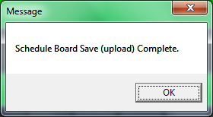 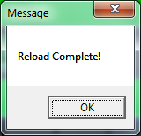

After the re-load has completed, the user is prompted.

Import Data CollectiondataCollection.bmp will prompt the user whether or not to Import Data Collection transitions.

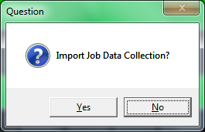Importing this data will attempt to match up any Schedule Board Jobs with the Data Collection transactions and setting the Starting Date & Time of a Job. The Job’s lock status will also be set to ON, thus preventing any move operations from effecting any Jobs locked with Data Collection transactions. This function allows the Schedule Board to accurately reflect real time operations on the production floor. NOTE: the ASI system has to have the Data Collection module installed and in use. Also, the startup parameters for the ASI system need to be connected to the “EMPTRACK” database found in the “Add-On” directory structure.

The existence of the file “Vorne.dat” in the board ID directory “schedule/data/ASI/Folding” or “schedule/data/ASI/Corrugated” triggers the system use the values within this .dat file to load Vorne generated transactions. The file is structured as follows:

Line 1: <Directory where Vorne files are generated>

Line 2: <Detail/Summary> … how Vorne transactions are loaded into ASI

Line 3: <ASI/Vorne> … where employee logins originate, either through Touch Screen or from Vorne Transactions.

Line 4: <comma delimited list of machines to load or left as BLANK>

Sample shows the Vorne files are located in C:\Vorne, the transactions are in Summary form, the Employee Login is generated using the Vorne transaction value, and only machine 900 transactions are loaded.

c:\Vorne

Summary

Vorne

900

# Packing the Schedule Board

Pack by Job1408.gif when selecting a Job on the Schedule Board, the Pack button inherits the Job# value. When selecting to Pack a selected Job the following options are available:

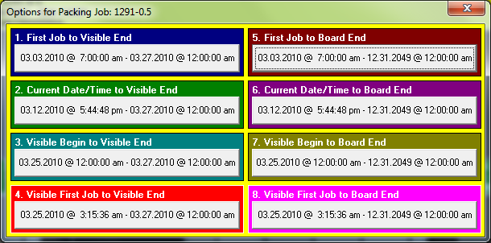

1. First Job to Visible End: beginning boundary will use the first job’s date & time on a Resource (machine), regardless of where it falls on the Schedule Board and the ending boundary using the date & time of the visible end, what the user can see as the ending boundary of what is visible.
2. Current Date/Time to Visible End: beginning boundary will use the current date & time as depicted by the red time line and the ending boundary using the date & time of the visible end, what the user can see as the ending boundary of what is visible.
3. Visible Begin to Visible End: beginning boundary will use the date & time of the visible start, what the user can see as the starting boundary of what is visible and the ending boundary using the date & time of the visible end, what the user can see as the ending boundary of what is visible.
4. Visible First Job to Visible End: beginning boundary will use the first visible job’s date & time on a Resource (machine), regardless of where it falls on the visible portion of the Schedule Board and the ending boundary using the date & time of the visible end, what the user can see as the ending boundary of what is visible.
5. First Job to Board End: beginning boundary will use the first job’s date & time on a Resource (machine), regardless of where it falls on the Schedule Board and the ending boundary using the date & time of the last job that is scheduled on the Schedule Board.
6. Current Date/Time to Board End: beginning boundary will use the current date & time as depicted by the red time line and the ending boundary using the date & time of the last job that is scheduled on the Schedule Board.
7. Visible Begin to Board End: beginning boundary will use the date & time of the visible start, what the user can see as the starting boundary of what is visible and the ending boundary using the date & time of the last job that is scheduled on the Schedule Board.
8. Visible First Job to Board End: beginning boundary will use the first visible job’s date & time on a Resource (machine), regardless of where it falls on the visible portion of the Schedule Board and the ending boundary using the date & time of the last job that is scheduled on the Schedule Board.

Pack by Resourcedomino1.gif when selecting a Resource (machine) on the Schedule Board, the Pack button inherits the Resource (machine) name value. When selecting to Pack a selected Resource (machine) the following options are available:

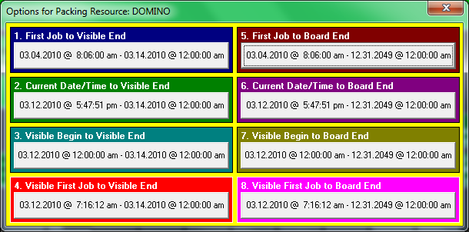See Pack by Job options above for explanation of the Options for Packing.

Pack All JobsentireBoard.bmp will perform a Pack operation on the entire Schedule Board based on the selection of one of the following options:

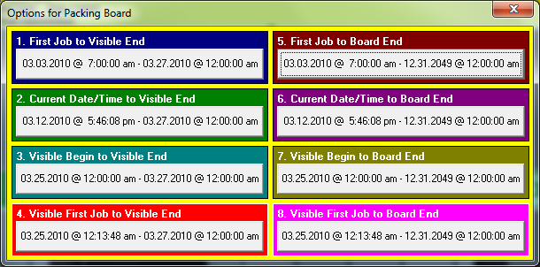See Pack by Job options above for explanation of the Options for Packing.

Use/Do Not Use Job Sequence Values When PackinguseSequenceOn.bmpuseSequenceOff.bmp will always default to Use Job Sequence Values. Normally when invoking move operations, the Job sequence set within each Resource (machine) is maintained. Turning this value OFF, will cause move operations to ignore any Job sequence settings and place Jobs using best fit algorithms. Understanding the impact of either setting has on movement operations is critical so that unexpected results do not occur.

Bring Past Jobs ForwardbringForward.bmp will shift the Schedule Board based on the desired selection when prompted. This process moves all Unlocked (Locked Jobs cannot be effected by any process involving Job movement operations) past Jobs to the current Date and Time.

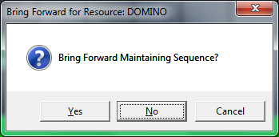 YES, will maintain the current sequence of the Jobs within each Resource (machine). NO, will cause the Schedule Board to simply move the Jobs forward and slot them in the best fit scenario, regardless of any type of criteria.

If an attempt if made to Bring Past Jobs Forward to a position other than the current date and time, the following prompt:

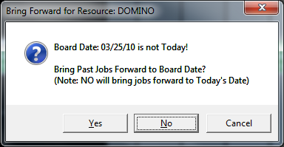 After selecting YES or NO, the user will be prompted whether or not to Maintain Sequences.

Set Beginning Grid Date is used to determine what date the Schedule Board begins its view. Pressing F1 will invoke a Calendar Popup for quick date selection.

Previous Dateprev.bmp will shift the Schedule Board to the prior date currently displaying.

Next Datenext.bmp will shift the Schedule Board to the next date currently displaying.

Popup Calendarcalendar.bmp invokes a popup for quick date selection.

Position Board to Current Date and Timeclock1.bmp will position the Schedule Board to the system’s Current Date and Time regardless of what date the current Schedule Board view is displaying.

Select Grid Interval allows the user to select how to view the Schedule Board by defining the Grid interval. The default setting for this field can be set under the Configuration tab.

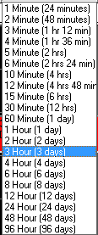

Move Back by Interval will shift the Schedule Board back by the selected Interval Grid.



Move Forward by Intervalnext.bmp will shift the Schedule Board forward by the selected Interval Grid.

Scenario: Actual (New). When the Schedule Board loads, it always defaults to “Actual” indicating the current Jobs on the Schedule Board and residing in Pending. Alternative “What if” Scenarios can be created by selecting “New”. This creates a duplicate copy of “Actual” (snap shot) and allows a user to change the Schedule Board without actually effecting real data in the ASI system. Remember it is only a snap shot and will grow stale as time progresses.

Save Scenariocommit.bmp saves the current Schedule Board, or if the Scenario selected is set to “New”, the user will be prompted to enter a Scenario name of the user’s choosing. When a “What if” scenario exists, it will appear as a selectable option under the Scenario pull down (combo-box) list. If the Scenario is “Actual”, the Schedule Board will auto SAVE giving the following prompt when completed. 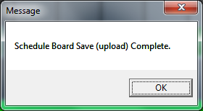 The Schedule Board can be configured to give an auto prompt to SAVE at designated time intervals. This value can be set under the Configurations tab. Each time a SAVE is performed, the running “Blue” clock will reset showing how old the currently visible Schedule Board is relative to the data that exists in the ASI system.

Remove Scenariorollback.bmp will delete an existing scenario provided it is not “Actual”. “Actual” scenarios cannot be removed.

Reset Board from Last Saverollback.bmp will restore the Schedule Board to the point of when the Schedule Board was opened or when the last SAVE operation was performed.

Pending by Jobpending.bmp accesses Pending Jobs so they can be scheduled by selected Job(s).

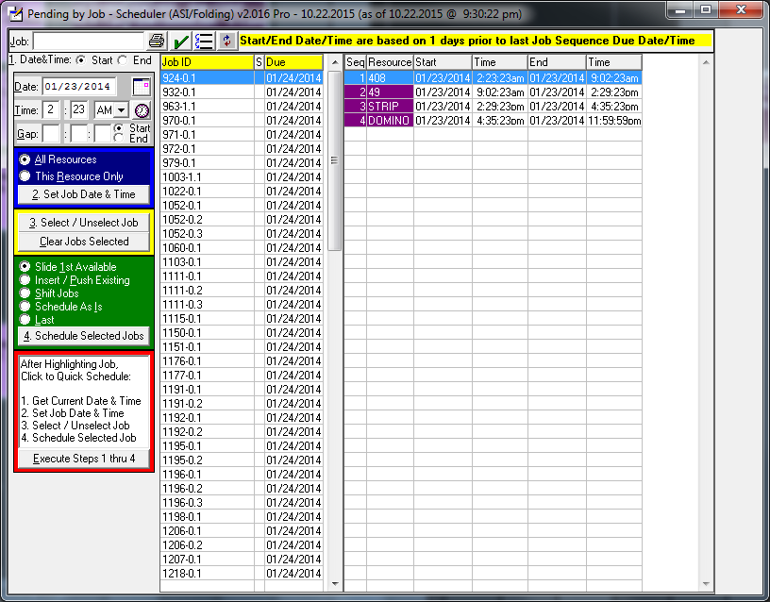

Typing a Job ID will auto filter each key stroke against the left side “Job ID” browser. Pending Jobs can be sorted either by Job ID or Due Date, simply click either column label. Repeated clicks to the column labels will toggle the sorting from Ascending to Descending, etc. The “S” column in the “Job ID” browsers indicates whether a Job has been selected to be scheduled by displaying a “Y”. The date/time values displayed are based on the subtracting one day from the Job’s Due Date and auto calculating backward from the last routing to arrive at the minimal Starting date/time needed in order the Job to complete on time. NOTE: these calculations do not take downtime or any existing Jobs scheduled to calculate at its displayed date/time values.

Printprint.bmp displays the Print Reports dialog pop-up, see documentation associated with the main Schedule Board screen further down in this document.

Job Status Check Offsave.bmp see documentation associated with the main Schedule Board screen further down in this document.

Move Resource (machine)moveResource.bmp provides the ability to move a selected Job(s) from one Resource (machine) to another. The documentation for this module can be found under prior headings for Move Resource.

There are five functional areas associated with this pending module.

1. 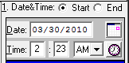 Date & Time (light gray area) is where a user decides which date/time values are to be adjusted. Either a Job’s starting date/time or it’s ending date/time. A date can be manually entered or selected using the calendar popupcalendar.bmp. Manually enter a time in hour, minutes and AM/PM values. To obtain the current date and time values, click the clockclock1.bmp icon.
2. 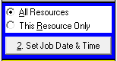 Set Job Date & Time (blue area) indicates where the above entered date/time values are applied. If “All Resources (machines)” is selected, the process will apply the date/time values to the either the start/end date/time fields (again based on above settings) and auto calculate the remaining date/time values, either forward or backward. If “This Resource Only” is selected, then only the highlighted Job routing selection is effected by the above entered values. This is accomplished by clicking “2. Set Job Date & Time” button.
3. 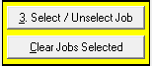 Select/Unselect Job & Clear Jobs Selected (yellow area) sets/unsets the “S” column value from either “Y” (selected to schedule) or BLANK (not selected for scheduling). Regardless of whether date/time values have been altered, a Job must be selected in order for it to be moved to the Schedule Board. The “Clear Jobs Selected” will remove all “Y” values to BLANK, thus unselecting all prior Jobs that were selected for scheduling. A Job can be selected/unselected by simply double clicking the Job ID value in the “Job ID” browser on the left side.
4. 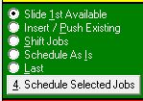 Schedule Selected Jobs (green area) tells this process where/how to place the selected Pending Jobs into the Schedule Board. Once one of the four options is selected, click “4. Schedule Selected Jobs” button to move the Pending Job onto the Schedule Board.
   1. Slide 1st Available will attempt to place the Job on its respective Resource (machine) based on a best fit logic. It starts to look for a large enough opening on the Resource (machine) based on its starting date/time values. Once it finds a time block large enough to hold the Job, it will set its starting date/time accordingly.
   2. Insert/Push Existing will attempt to place the Job at its starting date/time, should any other Jobs already exist at the starting date/time, the Pending Job will inherit the existing Jobs starting date/time values and push any other existing Jobs out into future date/times.
   3. Shift Jobs will place the Job at its starting date/time, should any other Jobs already exist within the starting and ending date/time range, those existing Jobs will be pushed out into future date/times.
   4. Schedule As Is will absolutely place the Pending Job at its starting date/time regardless of whether any other Jobs exist within the Pending’s start and end date/time range. Existing Jobs will not be effected, moved or shifted.
   5. Last will simply place the Pending Job as the last job of its associated resource.
5. 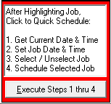 Execute Steps 1 thru 4 (red area) is a designed short cut to execute steps 1 thru 4 with just one click. This selection will set the Date & Time (light gray area) values based on the system’s current date and time. Will apply those date and time values to the selected Job/Resource (machine) (blue area). Auto select (yellow area) the highlighted Job. And schedule (green area) the selected Job based on whatever option has been chosen. This is an extremely useful method when simply moving Pending Jobs onto the Schedule Board one after another based on a pre determined order in which the Jobs are to be produced.

Pending by ResourcependingJobs.bmp accesses Pending Jobs so they can be scheduled by a selected Resource (machine).

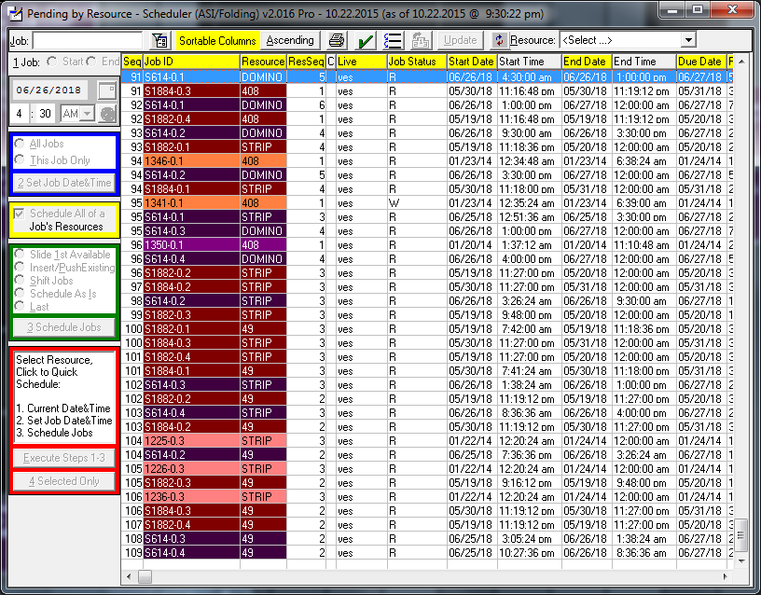

Appling focus to the browser allows a user to simply type a Job# and the browser will auto filter to a desired selection(s). Focus can also be applied to the “Job:” field, typing all or partial Job# value and either tabbing out of the field or pressing the Enter key. Any column with a Yellow header label can be clicked to sort the browser by that column. Most any column can be sorted, usually only columns with time values cannot be sorted on. Clicking the Ascending/Descending button with resort the columns accordingly. The browser can be filtered on an individual Resource by selecting a desired Resource from the pull down (combo-box) list. The starting and ending date/time values displayed are based on the subtracting the number of days value set in the configuration tab from the Job’s Due Date and auto calculating backward from the last routing to arrive at the minimal Starting date/time needed in order the Job to complete on time. NOTE: these calculations do not take downtime or any existing Jobs scheduled to arrive at its date/time values.

Set Filter ValuesfilterWindow.bmp displays a pop-up allowing entry of beginning and ending values used to filter the Job Browser. After values to filter are entered, press the APPLY and the Job Browser will be filtered based on the entered values. These filter values will only be in effect as long as the Set Filter Values pop-up remains open. Once the Set Filter Values pop-up is Exited, the filtering values on the Job Browser are cancelled.

Printprint.bmp displays the Print Reports dialog pop-up, see documentation associated with the main Schedule Board screen further down in this document.

Job Status Check Offsave.bmp see documentation associated with the main Schedule Board screen further down in this document.

Move Resource (machine)moveResource.bmp provides the ability to move a selected Job(s) from one Resource (machine) to another. The documentation for this module can be found under prior headings for Move Resource.

Auto Sequencesetseq.bmp will only enable after selection of a specific Resource (machine) from the pull down (combo-box). This will auto sequence the Jobs filtered for display. This sequence dictates how the Jobs are moved from Pending to the Schedule Board after clicking YES to the following prompt:

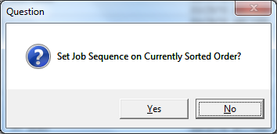

Update Job allows the user to manually set the sequence value. This button will only enable after selection of a specific Resource (machine) from the pull down (combo-box). Any of three methods can be used to gain access to the Sequence field. 1. Click the Update Job button. 2. Double click the Job record. 3. Press the Enter key of the Job record. This enables the Sequence field for a manual entry of a sequence value.



After selecting a specific Resource (machine), the sequence and update buttons enable. Also, the five functional areas are enabled.

There are five functional areas associated with this pending module.

1.  Date & Time (light gray area) is where a user decides which date/time values are to be adjusted. Either a Job’s starting date/time or it’s ending date/time. A date can be manually entered or selected using the calendar popupcalendar.bmp. Manually enter a time in hour, minutes and AM/PM values. To obtain the current date and time values, click the clockclock1.bmp icon.
2.  Set Job Date & Time (blue area) indicates where the above entered date/time values are applied. If “All Resources (machines)” is selected, the process will apply the date/time values to the either the start/end date/time fields (again based on above settings) and auto calculate the remaining date/time values, either forward or backward. If “This Resource Only” is selected, then only the displayed Job routing selection is effected by the above entered values. This is accomplished by clicking “2. Set Job Date & Time” button.
3. Untitled-4.gif When moving a Pending Job to the Schedule Board, selecting “Schedule All of a Job’s Resources” (yellow area) will cause all of a Job’s routing to also move to the Schedule Board. Not selecting this option, only the Job Routing selected will move and it’s remain routing records will still remain in Pending.
4. 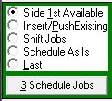 Schedule Jobs (green area) tells this process where/how to place the displayed Pending Jobs into the Schedule Board. Once one of the four options is selected, click “4. Schedule Jobs” button to move the Pending Job onto the Schedule Board.
   1. Slide 1st Available will attempt to place the Job on its respective Resource (machine) based on a best fit logic. It starts to look for a large enough opening on the Resource (machine) based on its starting date/time values. Once it finds a time block large enough to hold the Job, it will set its starting date/time accordingly.
   2. Insert/Push Existing will attempt to place the Job at its starting date/time, should any other Jobs already exist at the starting date/time, the Pending Job will inherit the existing Jobs starting date/time values and push any other existing Jobs out into future date/times.
   3. Shift Jobs will place the Job at its starting date/time, should any other Jobs already exist within the starting and ending date/time range, those existing Jobs will be pushed out into future date/times.
   4. Schedule As Is will absolutely place the Pending Job at its starting date/time regardless of whether any other Jobs exist within the Pending’s start and end date/time range. Existing Jobs will not be affected, moved or shifted.
   5. Last will simply place the Pending Job as the last job of its associated resource.
5. 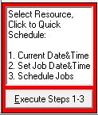 Execute Steps 1 thru 3 (red area) is a designed short cut to execute steps 1 thru 3 with just one click. This selection will set the Date & Time (light gray area) values based on the current date and time. Will apply those date and time values to the selected Job/Resource (machine) (blue area). Check the selection (yellow area) on whether to move a Job’s entire routing records or not. And schedule (green area) the displayed Job(s) based on whatever option has been chosen. This is an extremely useful method when simply moving Pending Jobs onto the Schedule Board one after another based on a pre determined order in which the Jobs are to be produced.

Job Status Check Offsave.bmp accesses a Job’s status values. Which Job Status Check Off’s appear and are utilized are setup under the Configuration tab. Every Job inherits all of the Check Off’s whether or not a Status is relevant to a particular Job. Currently, the only Status Check Off that is auto filled, is “Board”. If receipt of “Board” is utilized in the ASI system, the Schedule Board will auto fill this value. Status Check Off values can be maintained and communicated to the Schedule Board via an external module that allows other users to enter Status Check Off’s for currently Open and not Run Completed Jobs.

As of v2.000 the following Job Material Types are auto loaded (they must be receipted against a Job with the ASI system):

* W/F Board (Advantzware Material Type = B)
* W/F Cut Die (Advantzware Material Type = 8)
* W/F Flat Die (Advantzware Material Type = X)
* W/F Rotary Die (Advantzware Material Type = Y)
* W/F Plates (Advantzware Material Type = 7)
* W/F PVC or Paper (Advantzware Material Type = P)
* W/F Cases (Advantzware Material Type = C)
* W/F Foil (Advantzware Material Type = F)
* W/F Glue (Advantzware Material Type = G)
* W/F Foam (Advantzware Material Type = 1, 2,3 ,4 )
* W/F Pads (Advantzware Material Type = 5)
* W/F Dividers (Advantzware Material Type = 6)
* W/F Wax or Window (Advantzware Material Type = W)
* W/F Litho Labels (Advantzware Material Type = L)
* W/F Ink (Advantzware Material Type = I)
* W/F Coating (Advantzware Material Type = V)

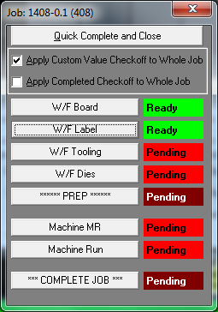 To Check Off a Status, click the desired Button. Clicking any Status Check Off button will toggle the Status from Ready to Pending and visas versa. When done, click the Close (red X) in the upper right corner. Clicking the “COMPLETE JOB” button, will toggle all Status to Ready and/or Pending, depending on its original value. To save mouse clicks, if a user simply desires to Run Complete a Job, select “Quick Complete and Close” option. This sets all Status Check Offs to READY and auto closes this popup. Depending on the two values for “Apply Custom Value Checkoff to Whole Job” and “Apply Completed Checkoff to Whole Job”, dictates how the Check Offs are applied. If “Apply Custom Value Checkoff to Whole Job” is selected, any Status Check Off changes will apply to all of a Job’s Routings, as opposed to just the selected Routing. If “Apply Completed Checkoff to Whole Job”, when a Run Complete is set, it will apply to the entire Job Routings. If would have the effect of removing an entire Job and all its routings from the Schedule Board. The default setting for these two values are determined by the value settings found in the Configurations tab.

Job NotesnoteTack.bmp accesses a Job’s Notes, these are unique Notes associated with a Job and it’s Routing Resource (machine). These differ from the ASI system notes, which appear on a Job Ticket. Job Notes created within this function will appear on any of the Schedule Board reports.

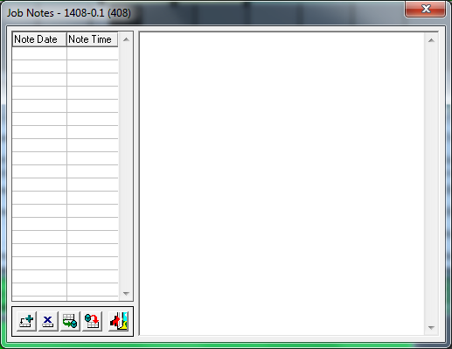

Add New Job Noteadd.bmp creates a new Job note.

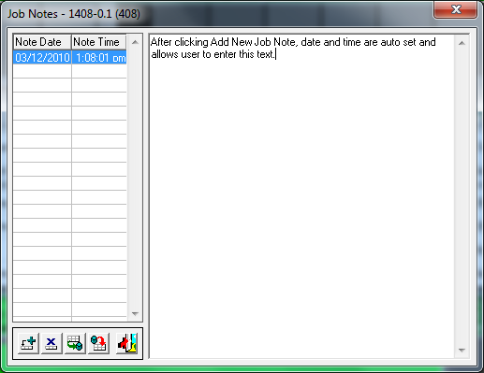

Delete Job Notecancel.bmp removes the currently highlighted note. The user is then prompted to continue deleting the selected Job Note.

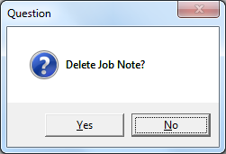

Save Job Notecommit.bmp commits changes to currently highlighted note. After clicking to save, the user is prompted to apply this note to all of the Job’s Resources (machine routings). YES will then create a copy of this note to any existing routings for this Job. NO indicates that this note will only appear for this routing.

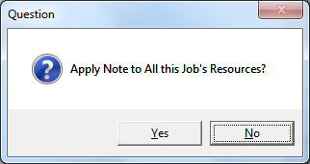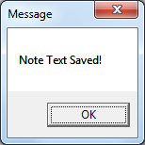

Reset Job Noterollback.bmp will restore original Job note values. Highlighted Job Notes are automatically in update mode. Once selected, a user simply makes desired changes to a Note’s text. Anytime before a SAVE operation, the user can restore a Note by clicking the Reset Job Note.

Exit Job Notesexit1.bmp closes Job Notes popup.

Turn Date Prompt On/OffdateOff.bmpdateOn.bmp enables and/or disables the Date Prompt popup. When dropping and dragging a Job to a new location, if this function is on/off, dictates how the end move process will behave. If the Date Prompt is disabled, the Job will try to utilize the date and time of the location where the Job is released by the user. However, if the Date Prompt is enabled, the user is provided with a popup dialog allowing specific date and time entries to dictate the exact location of the Job within the Schedule Board.

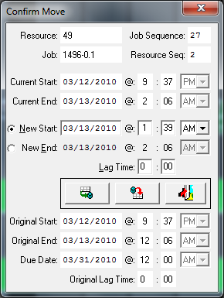 A Job’s date and time can be set to apply against its Starting Date and Time, or against its Ending Date and Time (causing the process to auto calculate the Job’s Starting Date and Time). This popup also allows the entry of Lag Time. This value dictates how much time much pass before the next routing can begin. When this value is zero, the next routing will not be scheduled to begin until after the previous routing has fully completed. By setting this value, a routing in process can have its quantity produced-to-date to be moved ahead to the next routing.

Save Date and Timecommit.bmp applies entered values and positions the Job on the Schedule Board accordingly.

Reset Date and Timerollback.bmp to its original values when first invoked. The original values used are displayed in the lower half of the Date Prompt popup.

Cancel with No Changesexit1.bmp closes the Date Prompt popup with no effect to the Job, causing the Job to return to its original location.

Hide/Show DowntimedowntimeOn.bmpdowntimeOff.bmp will hide and/or show the downtime images that appear on the Schedule Board. When downtime to hidden, any operations executed will still take downtime configurations into consideration and react accordingly.

Job Detail Popup Off/OndetailWinOff.bmpdetailWinOn.bmp allows user to enable/disable the Job Detail Popup from appearing when a Job is selected and/or highlighted. When enabled (ON), when a Job is selected the Job Detail Popup appears offering various detailed information from within the ASI system.

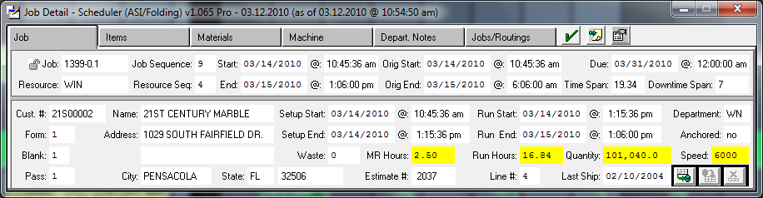

Job Header tab information

Job Capacity Updatecommit.bmp allows changing a Job’s MR Hours, Run Hours, Quantity and Speed. Updating these values is a LIVE data update which occur real time as opposed to most other changes, which only take effect when the Schedule Board is SAVED.

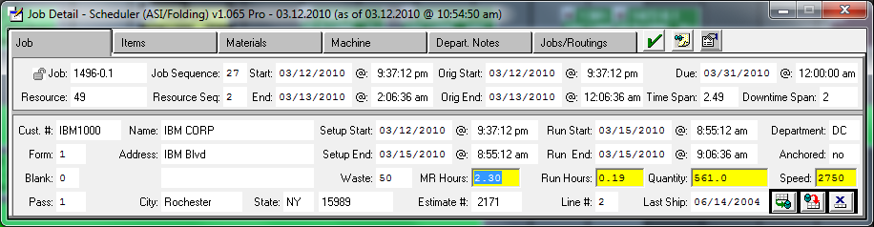

Job Capacity Resetrollback.bmp will set MR Hours, Run Hours, Quantity and Speed values back to the last SAVED values.

Job Capacity Cancel Updatecancel.bmp will exit the Update mode and any changes entered are automatically cancelled returning the MR Hours, Run Hours, Quantity and Speed to their original values respectively.

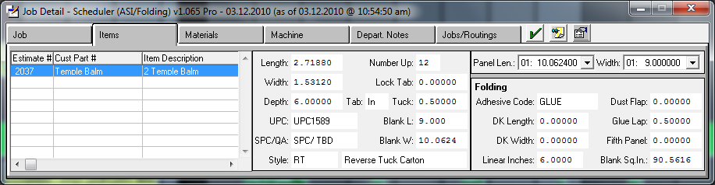

Job Items tab information

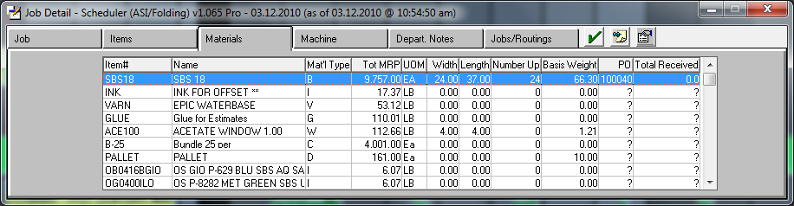

Job Materials tab information

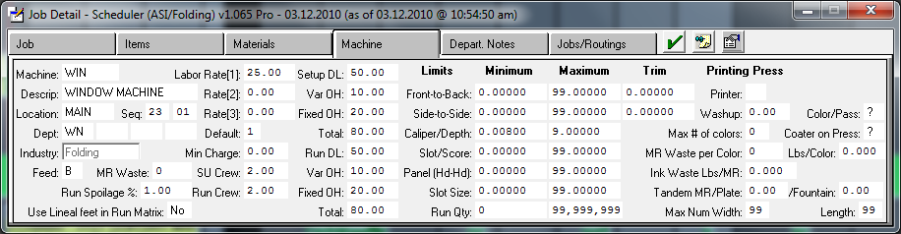

Job Machine tab information

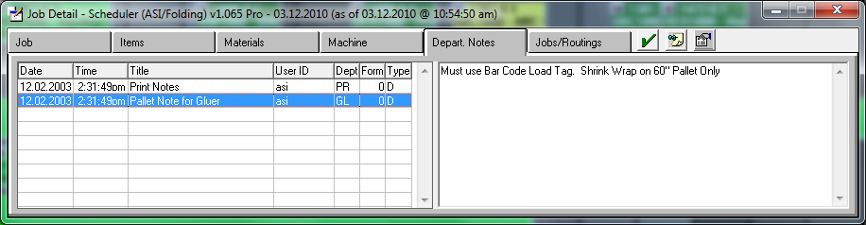

Job Department Notes tab information (these are the notes that appear on the Job ticket).

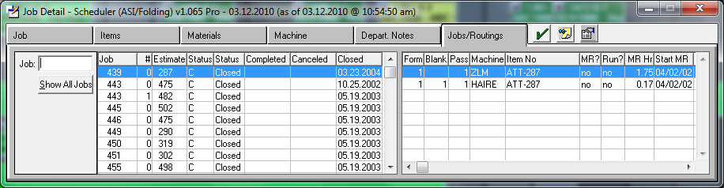

Job/Routings tab (often referred to as a mini J-U-1 option [Routings Tab]). This tab shows data that is not directly related to the selected Job which invoked the Job Detail Popup. This tab allows access to all the Jobs within the ASI system. A user can enter any Job# to ascertain a Job’s Routing information.

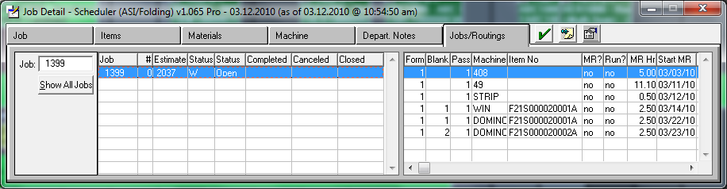Should a Job’s Run Completed flag inadvertently be set to YES, this Tab will allow the user access to change its value back to NO.

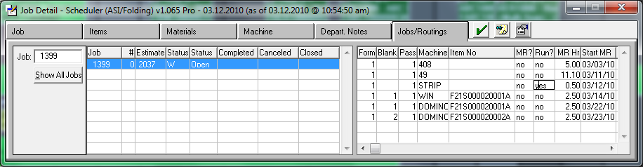Afterward, a Schedule Board reload will cause this Job to now appear and/or removed depending on the Run Completed flags value of Yes or No.

Job Status Check Offsave.bmp see previous documentation associated with the main Schedule Board screen.

Job NotesnoteTack.bmp see previous documentation associated with the main Schedule Board screen.

Job Data CollectiondataCollection.bmp accesses a Job’s Data Collection transactions. These transactions are the real time transactions done through Touch Screen and/or ASI Data Collection. Transactions displayed can be posted and/or un-posted transactions. Transactions displayed are all transactions associated with a Job regardless of resource (machine). The transactions can be filtered on a selected resource.

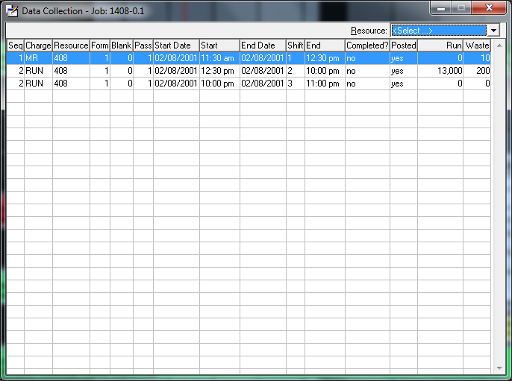

Turn Highlight Off/OnlightBulbOff.bmplightBulbOn.bmp allows users to enable/disable displaying a selected Job with a configuration determined color. When a Job is selected and this function is enabled, the Job selected and any related Jobs based on the Routing of the selected Job are also highlighted. Regardless of whether this function is enabled or not, the selected Job’s routing will highlight color bars to the left and right of the Resource buttons featured on the left side of the Schedule Board.

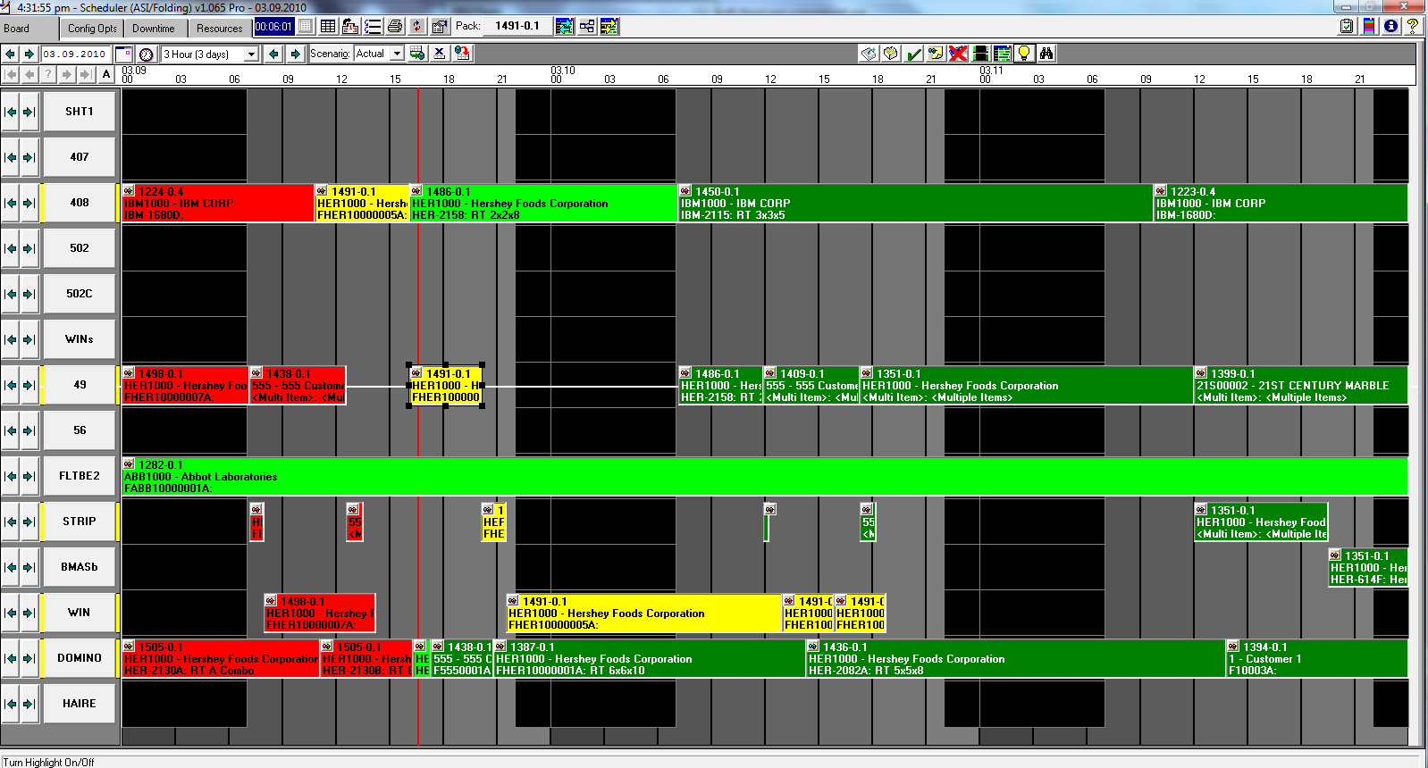Note: selected Job is highlighted as Yellow and black resize handles. Five other Job’s related to the selected Job (based on Routing) are also Yellow highlighted, however this Job actually has six other components as reflected by the five Resource buttons on the left show Yellow bars to the left and right giving notice that one part of the Routing is not visible within this view of the Schedule Board.

Job Browsefind.bmp accesses pop-up displaying all the Jobs currently found on the Schedule Board.

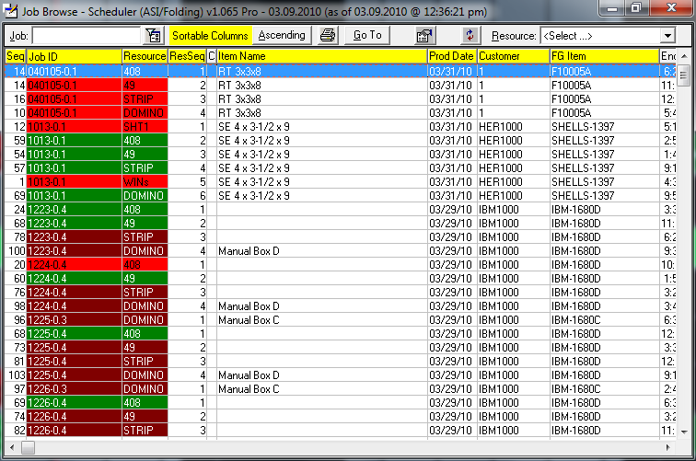Appling focus to the browser allows a user to simply type a Job# and the browser will auto filter to a desired selection(s). Focus can also be applied to the “Job:” field, typing all or partial Job# value and either tabbing out of the field or pressing the Enter key. Any column with a Yellow header label can be clicked to sort the browser by that column. Most any column can be sorted, usually only columns with time values cannot be sorted on. Clicking the Ascending/Descending button will resort the columns accordingly. A user can double click a highlighted Job or click the “Go To” button and the Schedule Board will be repositioned to the selected Job. The browser can be filtered on an individual Resource by selecting a desired Resource from the pull down (combo-box) list.

Set Filter ValuesfilterWindow.bmp displays a pop-up allowing entry of beginning and ending values used to filter the Job Browser. After values to the filter are entered, press the APPLY and the Job Browser will be filtered based on the entered values. These filter values will only be in effect as long as the Set Filter Values pop-up remains open. Once the Set Filter Values pop-up is Exited, the filtering values on the Job Browser are cancelled.

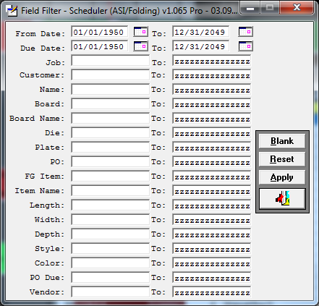 Beginning and Ending range fields can be removed and additional fields can be added to this Field Filter dialog box utilizing functionality within Browser Column Order and Report Layouts grids.bmp module.

Printprint.bmp displays the Print Reports dialog pop-up.

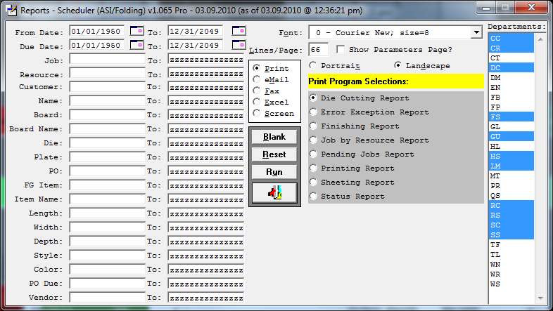 Beginning and Ending range fields can be removed and additional fields can be added to this Field Filter dialog box utilizing functionality within Browser Column Order and Report Layouts grids.bmp module. For details see the Print documentation associated with the main Schedule Board.

Access Data CollectiondataCollection.bmp displays detailed transaction records for any Data Collection associated with the currently highlighted Job.

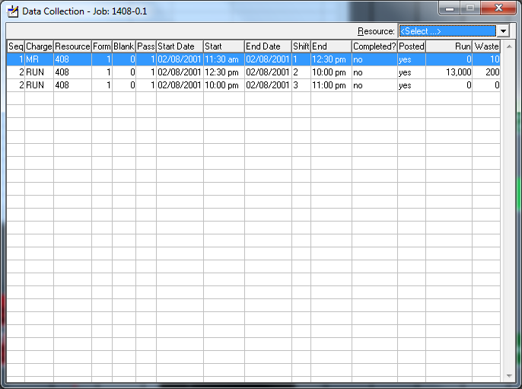The display will show all transactions for a selected Job regardless of the Resource. Transactions can be filtered using the Resource pull down (combo-box) and selecting a desired Resource.

Capacity ViewcapacityView.bmp displays a spread sheet like screen detailing Used and Available Hours or Kicks for any given Resource. By default the view is set for 30 days from the current date and can be easily expanded by setting the beginning and ending date values.

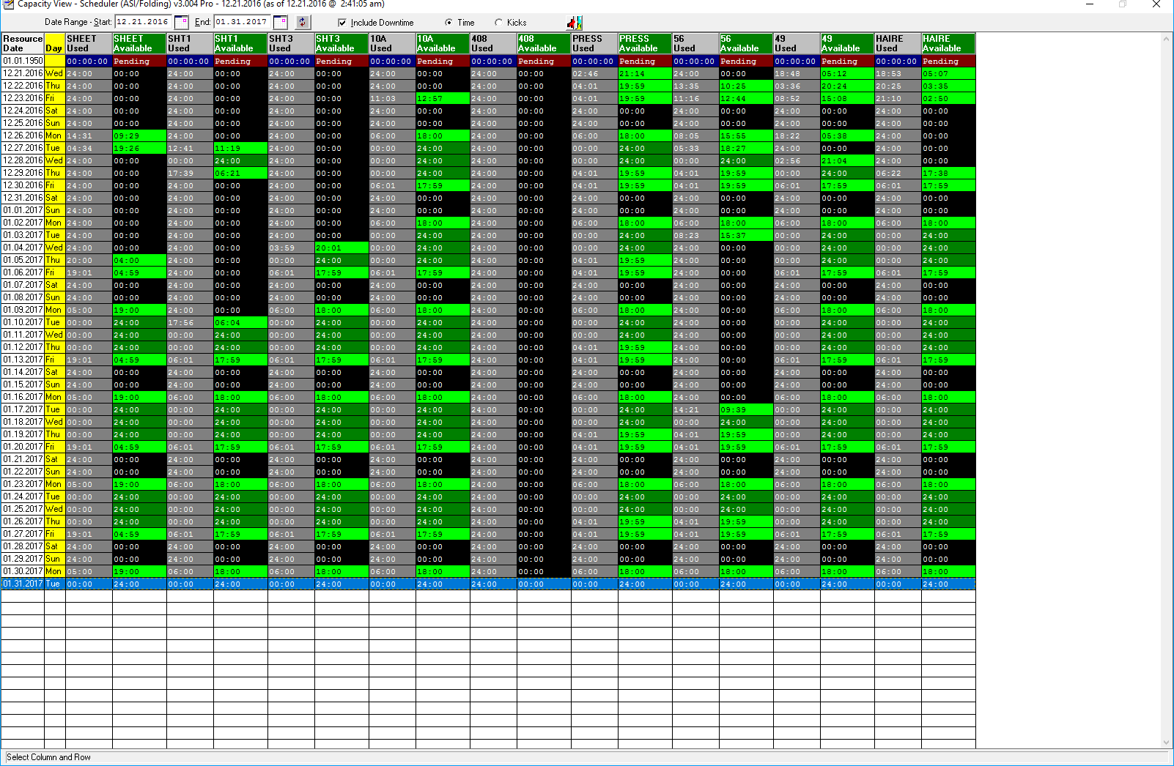Sample above shows Used and Available Hours.

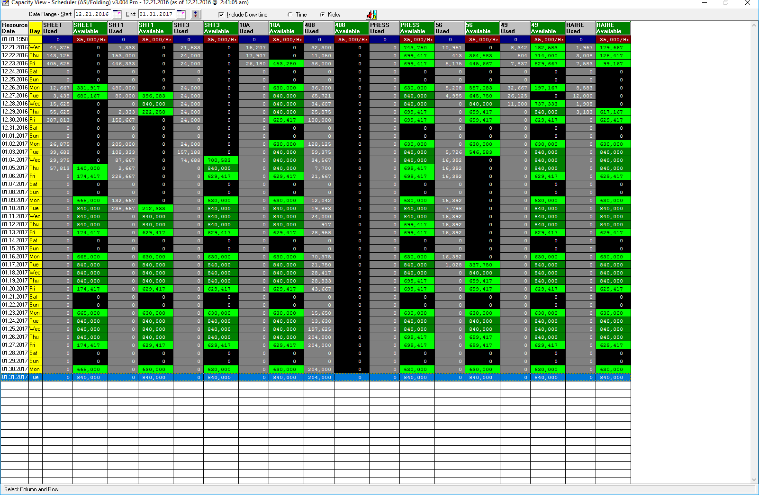

Sample above shows Used and Available Kicks.

The first row displays a date of “01.01.1950” as a way to place this data at the top of the display. It contains Used Hours or Used Kicks for Jobs that are found within the Pending tables. Pending Jobs are jobs which have not yet been placed on the Schedule Board. Toggling Include Downtime will calculate the Used values with or without Downtime factored, depending on this setting.

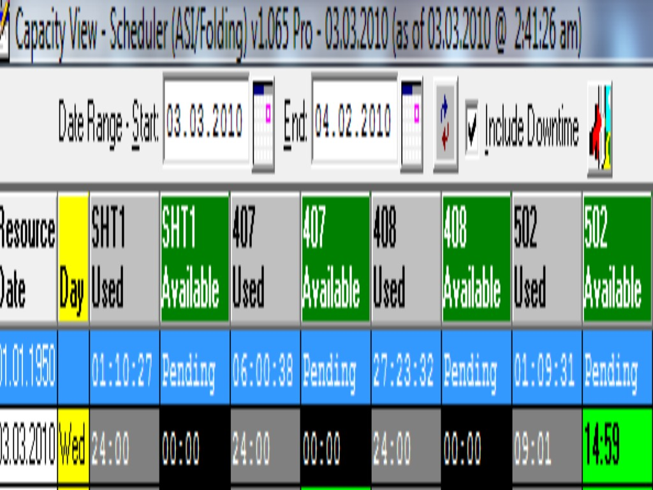

Refreshrefresh.bmp current display.

Exitexit1.bmp Capacity View.

Calendarcalendar.bmp popup allows a user to select a desire date with a point and click.

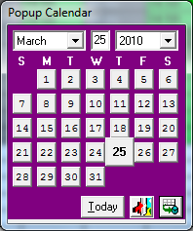

Color Legendlegend.bmp shows the various colors Jobs on the Board will display and their user defined definitions. “All Colors On” will cause each Priority to be selected. “All Colors Off” will cause each Priority to be unselected. Each individual Priority can be selected/unselected as desired. Click “Apply Selected Colors by Priority” to effect Job display colors based on selected Priorities.

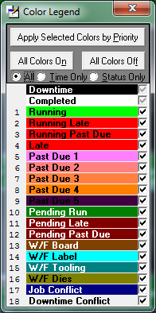

About (Support Contact Information) info.bmp 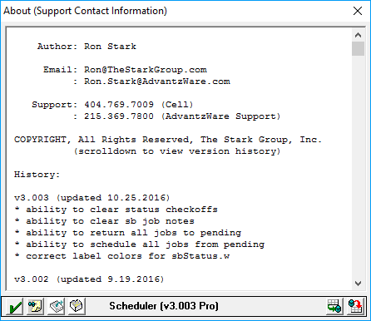

Clear Status CheckOffssave.bmp Allows user to Delete All the Status Check Offs. This may help resolve issues which occur when duplicate Status Check Offs have been used, then corrected. Once complete, a RELOAD will be auto performed.

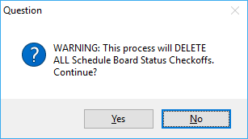

Clear Job NotesnoteTack.bmp Allows user to Delete All Schedule Board Job Notes. Once complete, a RELOAD will be auto performed.

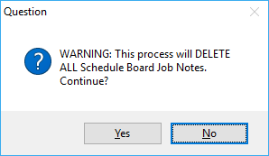

Return Jobs to Pendingpending.bmp Allows user to Return All Currently Schedule Jobs to Pending, essentially removing all jobs from the Schedule Board. Once complete, a RELOAD will be auto performed.

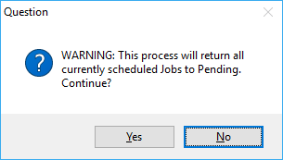

Move All Pending Jobs to the BoardpendingJobs.bmp Allows user to Schedule All Jobs from Pending, essentially removing all jobs from Pending.

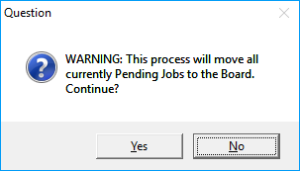

Savecommit.bmp Allows user to SAVE configuration files to a local drive. This prevents any updates and/or corruption causing configuration setting loss.

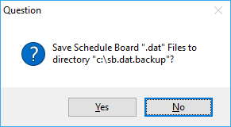

Restorerollback.bmpAllows user to **RESTORE** configuration files from a local drive.

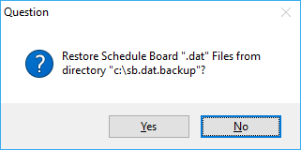

Help Documentationhelp.bmp If Microsoft Word is installed, this document will auto display.

# Resource (Machine) Detail Job Browse

Reposition to First Job for <Resource (machine)>first.bmp will shift the Schedule Board to the first existing Job for the selected Resource (machine).

Reposition to Last Job for <Resource (machine)>last.bmp will shift the Schedule Board to the last existing Job for the selected Resource (machine).

Detail Browser domino.gif will access a Job Browser specifically filtered on the selected Resource (machine) when double clicking any Resource (machine) button.

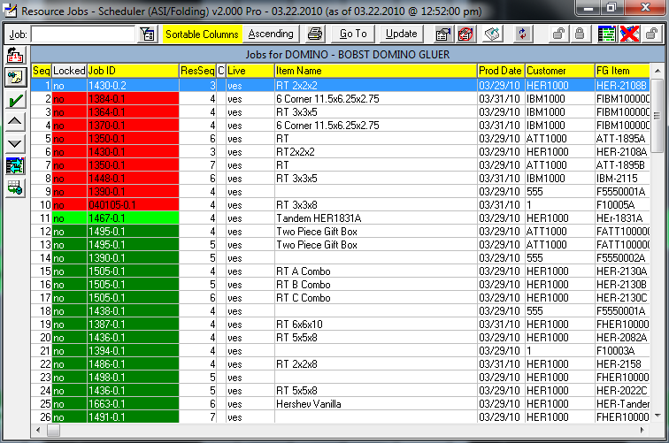 Appling focus to the browser allows a user to simply type a Job# and the browser will auto filter to a desired selection(s). Focus can also be applied to the “Job:” field, typing all or partial Job# value and either tabbing out of the field or pressing the Enter key. Any column with a Yellow header label can be clicked to sort the browser by that column. Most any column can be sorted, usually only columns with time values cannot be sorted on. Clicking the Ascending/Descending button will resort the columns accordingly. A user can double click a highlighted Job or click the “Go To” button and the Schedule Board will be repositioned to the selected Job.

Set Filter ValuesfilterWindow.bmp displays a pop-up allowing entry of beginning and ending values used to filter the Job Browser. After values to filter are entered, press the APPLY and the Job Browser will be filtered based on the entered values. These filter values will only be in effect as long as the Set Filter Values pop-up remains open. Once the Set Filter Values pop-up is Exited, the filtering values on the Job Browser are cancelled.

 Beginning and Ending range fields can be removed and additional fields can be added to this Field Filter dialog box utilizing functionality within Browser Column Order and Report Layouts grids.bmp module.

Printprint.bmp displays the Print Reports dialog pop-up.

 Beginning and Ending range fields can be removed and additional fields can be added to this Field Filter dialog box utilizing functionality within Browser Column Order and Report Layouts grids.bmp module. For details see the Print documentation associated with the main Schedule Board.

Update Job Sequence and Lock Values enables the Seq and Lock columns. A user can manually enter a Sequence value and change a Job’s Lock Yes/No value. Once a Job is locked, no move operation will alter the Job’s date/time values.

Access Data CollectiondataCollection.bmp displays detailed transaction records for any Data Collection associated with the currently highlighted Job.

The display will show all transactions for a selected Job regardless of the Resource. Transactions can be filtered using the Resource pull down (combo-box) and selecting a desired Resource.

Toggle Live Update SettingliveUpdate.bmp will set the “Live” column from either Yes to No, or No to Yes. When the value is Yes, any Import Data Collection will allow a Job’s date/time values to be altered based on any existing Data Collection transactions if found. The Job’s Lock status will also be set to Yes if transactions exists. If the Live value is No, any transactions, if they exist, will not have any effect on the Job whatsoever.

Lock Jobsunlocked.gif will set the “Lock” column value to “No” for all Job’s displayed in the browser. Job’s displayed can be effected by the “Job:” value and “Field Filter” values if open.

Unlock Jobslocked.gif will set the “Lock” column value to “No” for all Job’s displayed in the browser. Job’s displayed can be effected by the “Job:” value and “Field Filter” values if open.

Turn Job Display Window OndetailWinOff.bmp OffdetailWinOn.bmp, when ON, will cause the Job Detail Popup to be invoked when a Job is selected. If the detail popup is open and another Job is selected, the detail popup will auto refresh with the newly selected Job’s respective data values.

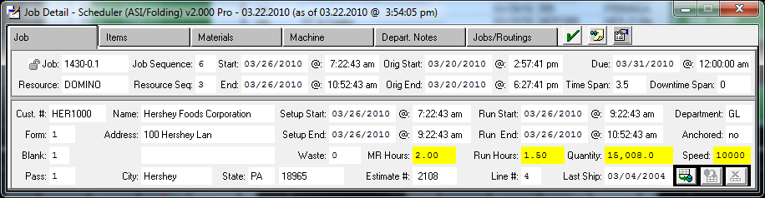Documentation detailing the functions available within the Job Detail Popup can be found further up in this document.

Turn Date Prompt Popup OndateOff.bmp OffdateOn.bmp, when ON, will and a Job is in UPDATE mode, the Date Prompt Popup will be invoked allowing the user to set the exact starting or ending date/time to precise values.

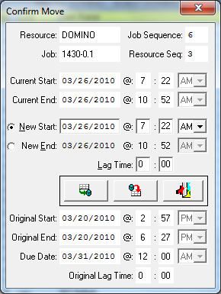

Lock Related Jobsunlocked.gif Unlock Related Jobslocked.gif, by default when a Job’s Lock value is changed (Yes/No), only the selected Job’s Lock status is affected. The browser title will normally appear as follows:

Untitled-2.gif

When the icon is toggled from an unlock appearance to a locked appearance, the title bar changes to:

Untitled-4.gif

And when a Job’s Lock value is now changed, the user is prompted with a reminder that a Job’s related routings have also been changed.

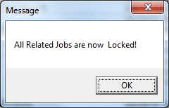 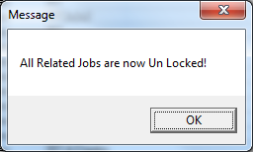

Auto Sequencesetseq.bmp will set the Job Sequence (“Seq” column) from 1 (one) to ..N, depending on the number of Job records contained within the browser. The number displayed is effected by the “Job:” value and whether the “Field Filter” popup is open with filter values. The user is presented with a prompt to continue.

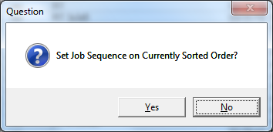

Job NotesnoteTack.bmp popup can be invoked, documentation for Job Notes usage can be found further up in this document.

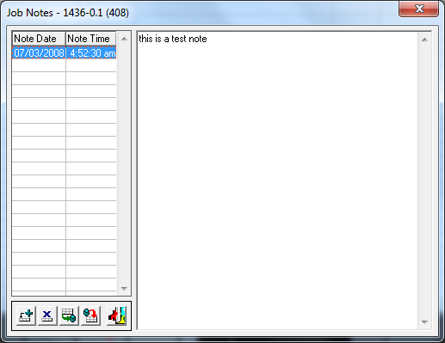

Complete Jobsave.bmp (Status Check Off) is invoked for the highlighted Job and its usage documentation is found further up in this document.

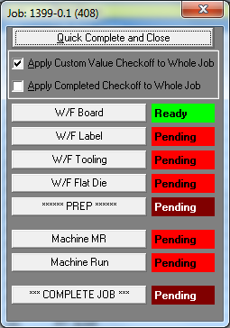

Increment Job Sequence Upup.bmp will change the Job Sequence (“Seq” column) up by 1 (one). The highlighted Job record will not reposition, only the “Seq” value will change. Simply click the “Seq” column header label to re-sort the browser records.

Increment Job Sequence Downdown.bmp will change the Job Sequence (“Seq” column) down by 1 (one). The highlighted Job record will not reposition, only the “Seq” value will change. Simply click the “Seq” column header label to re-sort the browser records.

Pack Selected JobentireBoard.bmp will prompt with the Options for Packing Job. An explanation for the eight options presented are detailed further up in this document.

Save (Pack Resource)commit.bmp will prompt with the Options for Packing Resource. An explanation for the eight options presented are detailed further up in this document.

# Advanced Job Drop & Drag Options

Move Job to another Resource (machine) is accomplished by selecting a job object and while holding the mouse button down, drag the job to the desired Resource (machine) button and with the upper top edge of the job object hovering over the Resource (machine) icon, let go of the mouse button and answer the prompt to continue.

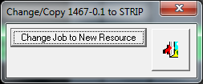 The job will be moved to the exact same date/time as the job’s current values, but on the newly chosen Resource (machine). If the selected job should be in conflict with an existing job on the new Resource (machine), four options are provided and/or this creates a downtime conflict. Explanation can be found for these two conflict types under Drop and Drag Jobs to New Position.

Drop and Drag Jobs to New Position is accomplished by selecting a Job object and while holding the mouse button down, drag the job to the desired position. If when dropping the job to its new position a conflict with another job occurs the following four options are provided to offer a solution.

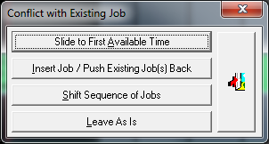

Slide to First Available Time will cause the job to search from its current starting date/time for a position that will allow its starting and ending range to fit without incurring any other type of conflict.

Insert Job/Push Existing Job(s) Back will set the moved jobs starting date/time from the existing job and push the existing job and subsequent jobs that follow in sequence to be pushed further back into the future.

Shift Sequence of Jobs will position the job at its current starting date/time and all other subsequence job that follow in sequence to be pushed further back into the future.

Leave As Is will use the moved jobs starting date/time to set its position regardless of whether an existing job is positioned with its starting and ending date/time range. Basically, it will leave the conflict creating overlapping jobs.

If a moved job should create a conflict with existing downtime, the following three options are provided.

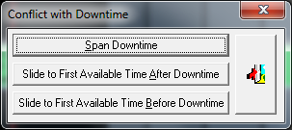

Span Downtime will allow the moved job to remain in its current starting date/time position and recalculate its ending date/time by figuring the length of time of the downtime block into the overall starting and ending date/time range.

Slide to First Available Time After Downtime will search for an available block of time immediately after the downtime in conflict using its ending date/time as its starting point.

Slide to First Available Time Before Downtime will search for an available block of time immediately before the downtime in conflict using its starting date/time as its ending point and working back in time.

Return Scheduled Job to Pendingpending.bmp pendingJobs.bmp by selecting a job object and while holding the mouse button down, drag the job to either the Pending by Jobspending.bmp or Pending by ResourcependingJobs.bmp icons. With the upper top edge of the job object hovering over either icon, let go of the mouse button and answer the prompt to continue. The user is prompted to select the routings to return to Pending. Thus, one or more of a Job’s Routings can be returned.

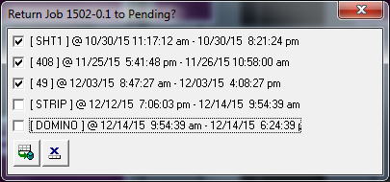

Accessing Job Notes via Pin IconnoteTackRed.bmp noteTack.bmp, push pin icon (red or green) will appear when the Notes: interval value is selected (see configuration default settings documentation above for explanation). A red pin icon indicates no job notes exist and a green pin icon indicates that job notes do exist. Clicking the pin icon invokes the Job Notes popup. See documentation above for detailed clarification.

Locking/Unlocking a Job via Lock Iconlocked.gif, lock icons will appear when the Locks: interval value is selected (see configuration default settings documentation above for explanation). A user can simply click to Lock and/or Unlock a job. Once a jobs lock has been set, no operations performed will cause the locked job to be altered from its locked position.

# CTRL Key Options (short cuts)

Lag Time (CTRL-L), after selecting a Job, type CTRL-L to invoke the following prompt:

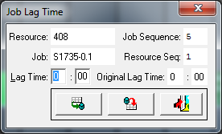

Enter the Lag Time Hours and Minutes, this allows the next Job’s routing to begin processing after the Lag Time has elapsed, as opposed to not being able to begin until the selected Job has completed entirely.

Save New Lag Time Valuecommit.bmp applies the values entered.

Restore Original Lag Time Valuerollback.bmp will undo any Lag Time changes entered and reset them back to their original values.

Cancel with No Changesexit1.bmp will discard any changes entered and exit the Lag Time popup.

Auto Find Next Job Routing (CTRL-N) is done by selecting a Job and typing CTRL-N (next). The Schedule Board will reposition to the Job’s Next Routing. If the selected Job object is the last routing, the Schedule Board will reposition to the first routing.

Auto Find Previous Job Routing (CTRL-P) is done by selecting a Job and typing CTRL-P (previous). The Schedule Board will reposition to the Job’s Previous Routing. If the selected Job object is the first routing, the Schedule Board will reposition to the last routing.

Status Check Off (CTRL-O) can be initiated by typing CTRL-O if a Job on the Schedule Board is selected.

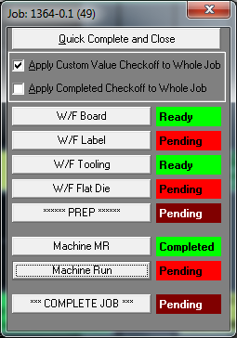

Explanation detailing the Status Check Off popup is located further up in this document.

Date Prompt (CTRL-D / CTRL-T) will cause the Date Prompt popup to be accessed if a Job on the Schedule Board is selected.

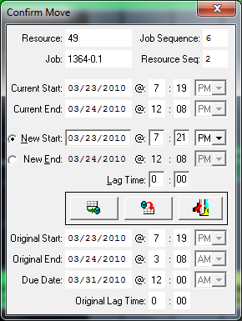

Explanation detailing the Date Prompt popup is located further up in this document.

Save (CTRL-S) can be initiated by typing CTRL-S.

Reset (CTRL-R) can be initiated by typing CTRL-R.